Impact of Natural Disasters Based on Satellite Images

San Jose State University  
Master of Science in Data Analytics



**Team 5**

Amar Ippili, Shubh Johri, Aarathi Nadathur, Divya Puraswani, Sameer Rajput

TABLE OF CONTENTS

ABSTRACT 9

1. INTRODUCTION 10

1.1 Project Goals and Background 10

1.2 Analysis of Requirements 17

1.3 Project Deliverables 20

1.4 Technology Trends and Solution Survey 21

1.5 Literature Survey of Existing Research 22

2. DATA EXPLORATION 24

2.1 Data Exploration Strategy and Planning 24

2.2 Data Sources and Dataset Parameters 26

2.3 Collection of Training Datasets 28

2.4 Data Cleansing and Validation 30

2.5 Data Transformation and Tools 32

2.6 Raw Data Visualization 34

3. PROJECT MANAGEMENT 38

3.1 Project Organization 38

3.2 Resource requirements 39

3.3 Project Schedule 40

4. PROBLEM FORMULATION AND MODEL SELECTION 41

4.1 Problem Formulation 41

4.2 Foundation of Proposed Solutions 44

4.3 Feature Engineering 46

4.4 Select and Justify Solution Model 49

4.5 Justify Solution Model 51

5. MODEL DEVELOPMENT AND PRESENTATION 53

5.1 Model Building and Training 53

5.2 Model Execution and Evaluation 61

5.3 Model Validation 64

6. EVALUATION AND VISUALIZATION 69

6.1 Analysis of Model Execution/Evaluation Results 69

6.2 Achievements and Constraints 73

6.3 Quality Evaluation of Model Functions and Performance 74

6.4 Evaluation of Models vs. Requirements 76

6.5 Information Visualization 78

7. CONCLUSION 87

7.1 Summary 87

7.2 Benefits and Shortcoming 88

7.3 Potential Model Applications 89

7.4 Lessons Learned 91

7.5 Recommendations for future work 92

7.6 Contributions and Impacts on Society 92

REFERENCES 94

**TABLE OF FIGURES**

**Figure 1: Earthquakes with the highest death toll worldwide from 1900 to 2016 11**

**Figure 2: Number of fatalities due to floods in U.S. from 1995 to 2018 12**

**Figure 3: Number of buildings destroyed due to wildfire in California from 1989 to 2017 13**

**Figure 4: Global deaths from natural disasters [8] 14**

**Figure 5: Architecture of the baseline classification model 16**

**Figure 6: Natural Disaster Scenario 17**

**Figure 7: Proposed Architecture 18**

**Figure 8: Model Pipeline 24**

**Figure 9: Data Frame view of the Feature Properties 26**

**Figure 10: Metadata values using python 28**

**Figure 11: Metadata values using python 28**

**Figure 12: Sample pre/post Mexico earthquake disaster image 29**

**Figure 13: Data Filtering 30**

**Figure 14: Polygons and Masked images 32**

**Figure 15: Geographical representation of data 34**

**Figure 16: Different countries and disasters 35**

**Figure 17: Different types of disasters 35**

**Figure 18: Mean GSD values per disaster 36**

**Figure 19: Different satellites used for capturing images 37**

**Figure 20: Project Hierarchy 38**

**Figure 21: Crisp-DM Process Model 39**

**Figure 22: Pert Chart 40**

**Figure 23: Diagrammatic Flow of the proposed solution 44**

**Figure 24: Feature Engineering 46**

**Figure 25: Setting up the hierarchy for model training 54**

**Figure 26: Pre-Disaster Earthquake Original Image (Left) and Masked Image (Right) 55**

**Figure 27: General U-Net Architecture 56**

**Figure 28: Polygon Extraction in process 58**

**Figure 29: Polygon Extraction in process 58**

**Figure 30: Test.csv showing uuid and labels (damage) 59**

**Figure 31: Train.csv showing uuid and labels (damage) 59**

**Figure 32: Polygon Extracted from image 60**

**Figure 33: Architecture of ResNet 60**

**Figure 34: Epochs Report 61**

**Figure 35: Accuracy Graph 62**

**Figure 36: Loss Graph 62**

**Figure 37: Segmentation with ground truth 63**

**Figure 38: ResNet Model Epoch 63**

**Figure 39: Pre-Disaster Image of Woolsey fire 64**

**Figure 40: Post-Disaster Image of Woolsey Fire 65**

**Figure 41: Masked Image of Woolsey fire (Pre disaster) 66**

**Figure 42: Output Image of Woolsey fire 67**

**Figure 43: Localization model confusion matrix 71**

**Figure 44: Damage Classification Imbalance 71**

**Figure 45: Classification Report 72**

**Figure 46: Classification Confusion Matrix 73**

**Figure 47: Elapsed time per epoch on GPU (U-Net Model) 75**

**Figure 48: Elapsed time for epochs on GPU (ResNet Model) 76**

**Figure 49: Map showing the disasters occurred in different country 78**

**Figure 50: Map showing disasters occurred in USA 78**

**Figure 51: Disaster Captured by Each Satellite 79**

**Figure 52: Disaster Impact 79**

**Figure 53: Damage Classification 80**

**Figure 54: Interactive Power BI Dashboard 80**

**Figure 55: Santa Rosa Wildfire, California – Pre/Post Disaster Images with Annotations 81**

**Figure 56: Santa Rosa Wildfire, California - Damage Building Location Map 82**

**Figure 57: URL for frontend interface 82**

**Figure 58: Data flow between user and server space 83**

**Figure 59: Model data flow 83**

**Figure 60: Front end - Overview tab 84**

**Figure 61: Front end - Dataset Tab 84**

**Figure 62: Front end - Analysis Tab 85**

**Figure 63: Front end - Output Image 85**

**Figure 64: Front end - Visualizations tab 86**

**Figure 65: Model Pipeline 88**

**TABLE OF TABLES**

**Table 1: Data Science Life Cycle 20**

**Table 2: Technology Trends and Solution Survey 21**

**Table 3: Comparison of research work conducted in disaster management 22**

**Table 4: Damage Scale 26**

**Table 5: Feature Description 27**

**Table 6: Count of train/test images in dataset 29**

**Table 7: Major Python libraries Used 33**

**Table 8: Major Tools Used 34**

**Table 9: Earthquake severity and damage 41**

**Table 10: Pre labelled damage scale 42**

**Table 11: Evaluation Metric for Localization 45**

**Table 12: Damage Classification Labels 45**

**Table 13: Irrelevant features of the dataset 47**

**Table 14: Relevant columns to be added 48**

**Table 15: Comparison of image segmentation techniques 50**

**Table 16: Justification of models 51**

**Table 17: Train-Test-Split for Localization 56**

**Table 18: Hyperparameters Used in Training 57**

**Table 19: Train-Test split ratio for classification 58**

**Table 20: Hyperparameters Used in Resnet 61**

**Table 21: Evaluation metrics for localization and segmentation 69**

**Table 22: Individual Model Elements 77**

# ABSTRACT

Being a sudden and terrible event in nature, natural disasters not only affect the environment but also impact individuals at the physical, mental and emotional levels. Technological advancements of studying images, acquired from a satellite can play an important role in knowing the impact of these disasters, which affects humanity in several areas. We will be proposing an integrated framework for natural disaster management helping in mitigating, preparing, responding and recovering from these disasters using a deep learning model. Our model will be built upon previous research by considering the impact of destruction on buildings, which will assist in relief efforts, rescue operations, and disaster responses.

Following the data science project lifecycle, the framework will start with collecting data from publicly available sources, followed by data scrubbing, exploring, featuring and modeling data using deep learning CNN models. Various performance measures like confusion matrix, sensitivity, specificity and classification report will be used to evaluate our model. Data visualization will be done using Python, Tableau and Power BI.

Our model will quantify the impact of natural disasters on buildings, using images collected pre and post the disaster, focusing on natural and man-made factors. The results of our analysis will help humanity to measure the impact and level of building destruction by using data science tools and techniques.

# 1. INTRODUCTION

## 1.1 Project Goals and Background

**1.1.1 Background**

Natural disasters are events which are caused by the natural forces of the earth and results in great damage and loss of human life. These events are out of human control, but the consequences of disasters overlap with the consequences of war or combat. There is human suffering caused by damage to life, infrastructure and personal property. These types of disasters include earthquakes, tsunami, floods, wildfires, volcanoes and hurricanes.

**Earthquake/Tsunami**

Earthquake is one of the most devastating natural disaster which destroys millions of properties and threaten human life. It is a sudden and violent shaking of earth surface leading to distortion of the ground. The seismic waves generated from it cause the ground to shake, which results into collapse of buildings and infrastructure. The collapse of these structures which are made from heavy material causes many deaths.

An earthquake can have multiple natural effects on the environment, which makes it an essential study to include in the report. Some primary effects of an earthquake are as follows: [1]

* Landslides

Landslides are caused by earthquakes by direct rupture and sustained shaking of unstable slopes. It flattens and destroy houses/buildings resulting in added loss of life.

* Tsunamis

Series of water waves caused by vertical movement of seafloor are tsunamis. In 2004, the tsunamis unleashed by the Indian Ocean earthquake killed a total of 223,000 people in Indonesia, Thailand, India and Sri Lanka. The Tohoku earthquake in 2011 created a great tsunami waves which destroyed the communities and killed about 18,000 people.

* Fires

Major source of damage after earthquakes is fires. Earthquakes can easily rupture natural gas mains and water mains, both contributing to the ignition of fires and hindering the efforts to control them. Most of the damage in 1906, San Francisco earthquake was caused by massive fires in the downtown area of the city. Around 25,000 buildings were destroyed by those fires, which were fueled by broken pipelines. In Japan, the Great Kanto earthquake caused a fire that killed around 92,000 people. Overall, more than 2.3 million people have died in 2,233 earthquakes from 1900 [2]. Figure 1 shows the death toll since 1900 due to earthquake [3].

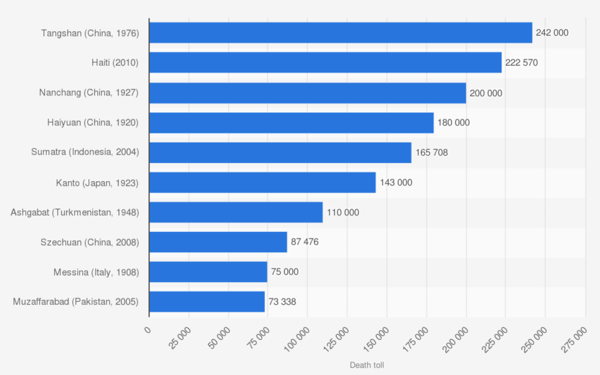

**Figure 1: Earthquakes with the highest death toll worldwide from 1900 to 2016**

**Floods**

Flood is one of the deadliest types of natural disaster which results from extreme rain, snow, storm surges and coastal storms. It causes outrages, disrupt transportation, damage buildings and create landslides. The main damage is caused due to the impact of rapid moving waters to the buildings. Flooding pushes the sides of the buildings, weakening the building’s structure and at times separating it from foundation. Floods are the most common natural disaster in the USA. In 2015 alone, flooding caused massive devastation in Texas and neighboring states; countless homes and buildings were damaged or destroyed [4]. Figure 2 shows the number of lives lost due to floods in the U.S. since 1995 [5].

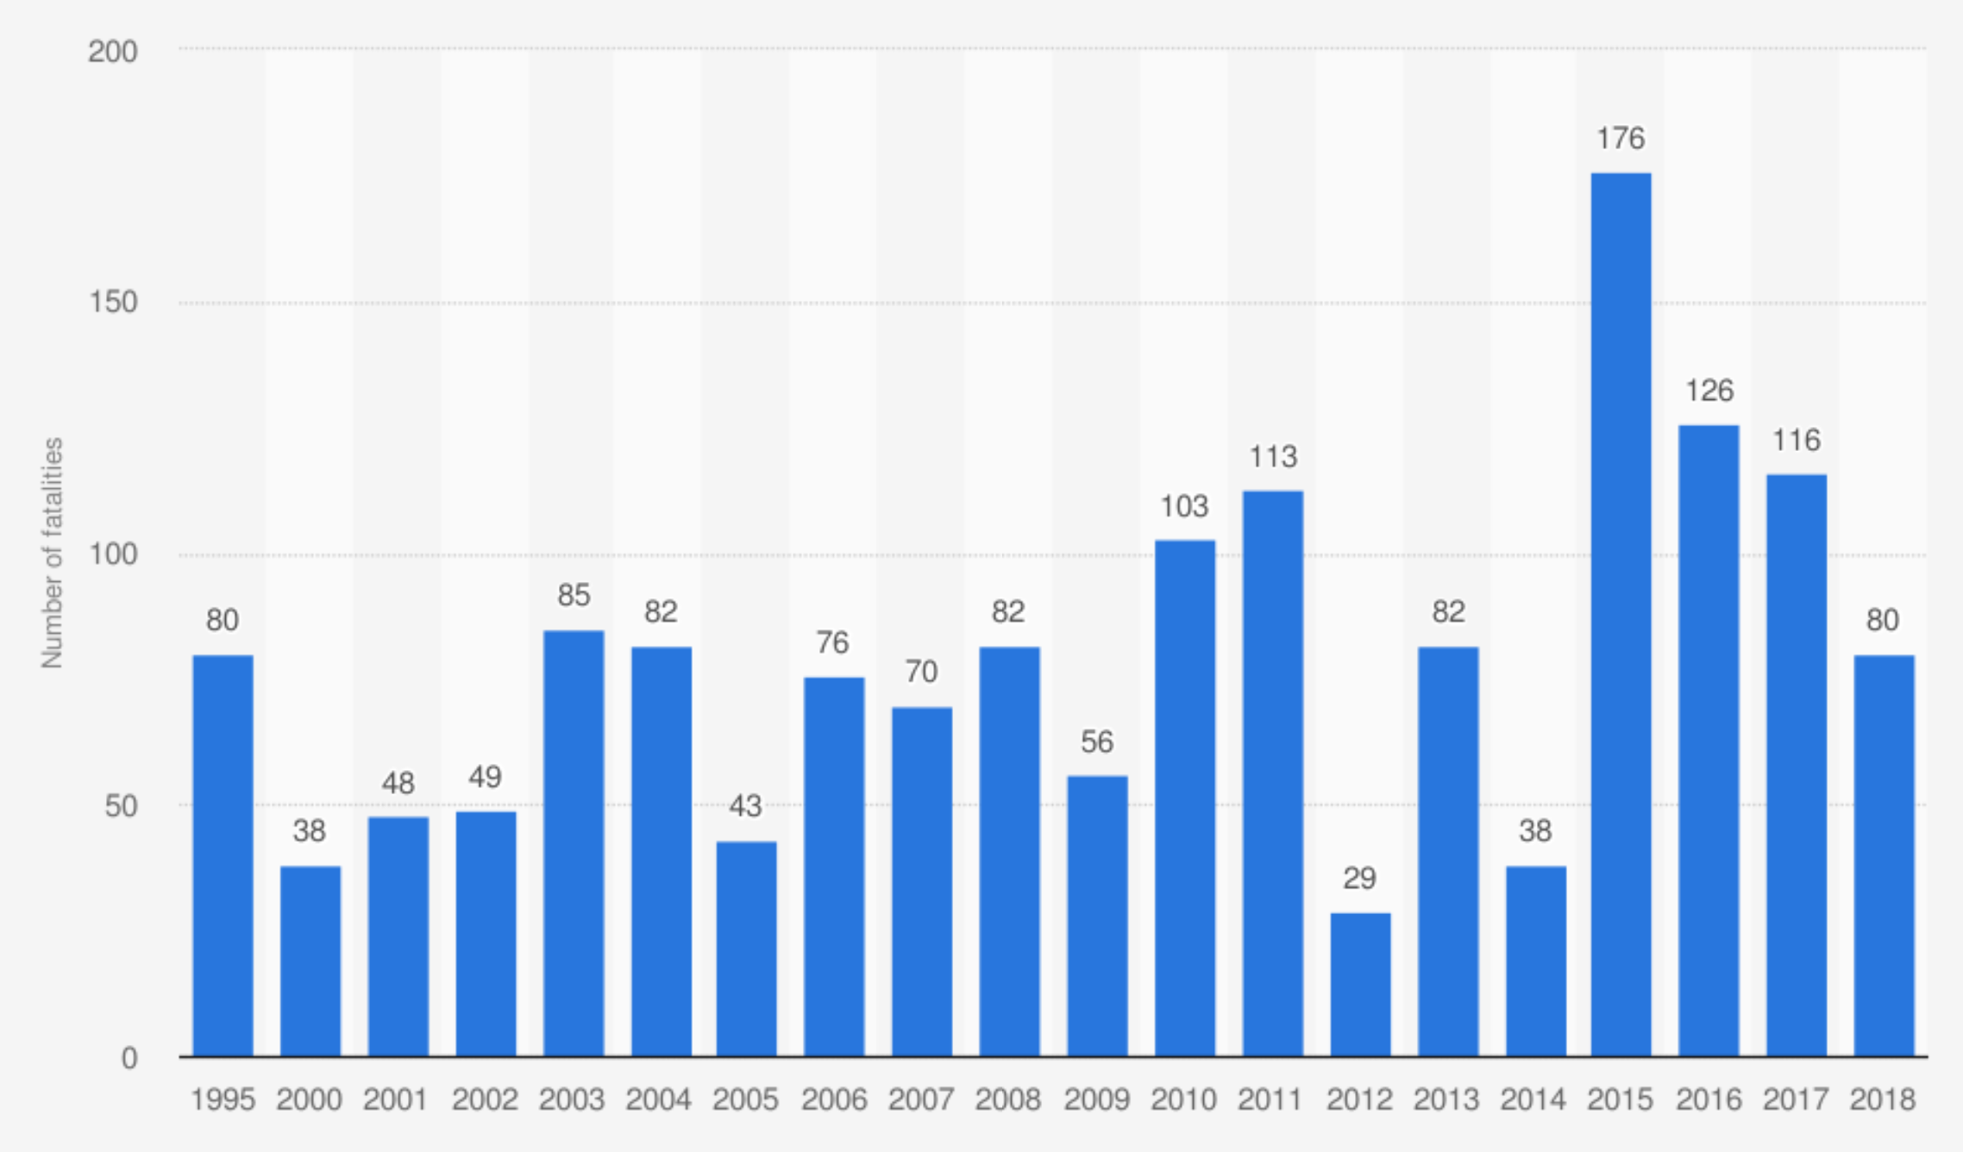

**Figure 2: Number of fatalities due to floods in U.S. from 1995 to 2018**

**Wildfires**

Wildfires are blazes that are not controllable and fueled by different types of weather, dry underbrush and winds, which burns land and take everything in their paths. There are about 100,000 wildfires in the USA every year. Over 9 million acres of land have been destroyed due to treacherous wildfires till now. In 2013, more than 47,500 wildfires were reported in the U.S that destroyed thousands of structures, including about 1,100 homes/buildings and burned more than 4 million acres of land. Figure 3 shows the number of buildings destroyed due to wildfires in California from 1989 to 2017. [6]

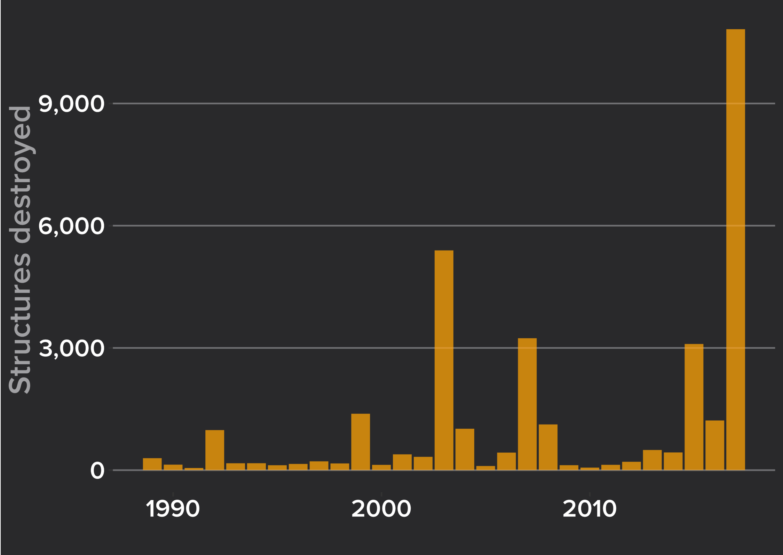

**Figure 3: Number of buildings destroyed due to wildfire in California from 1989 to 2017**

**Volcanoes**

Volcanoes are the vents or fissure in the earth crusts where lava, ash, rock and steam erupt on the earth’s surface. The fast-moving lava can destroy houses, buildings, roads and fields. Volcanic eruptions cause damage hundreds of miles away. The ash carpets the ground, burying everything and sometimes even causes buildings to collapse.

**Hurricanes**

A Hurricane is a large rotating storm with high velocity winds that forms over warm waters in tropical areas. The shear strength of hurricanes winds can destroy buildings, topple trees and damage infrastructure. In 2017, Hurricane Harvey first made destruction on San Jose Island, Texas with wind speed of 130 miles per hour. Then hit mainland Texas where it destroyed and damaged more than three hundred thousand structures [7].

Figure 4 shows overall global deaths due to natural disasters from 1996 to 2019.

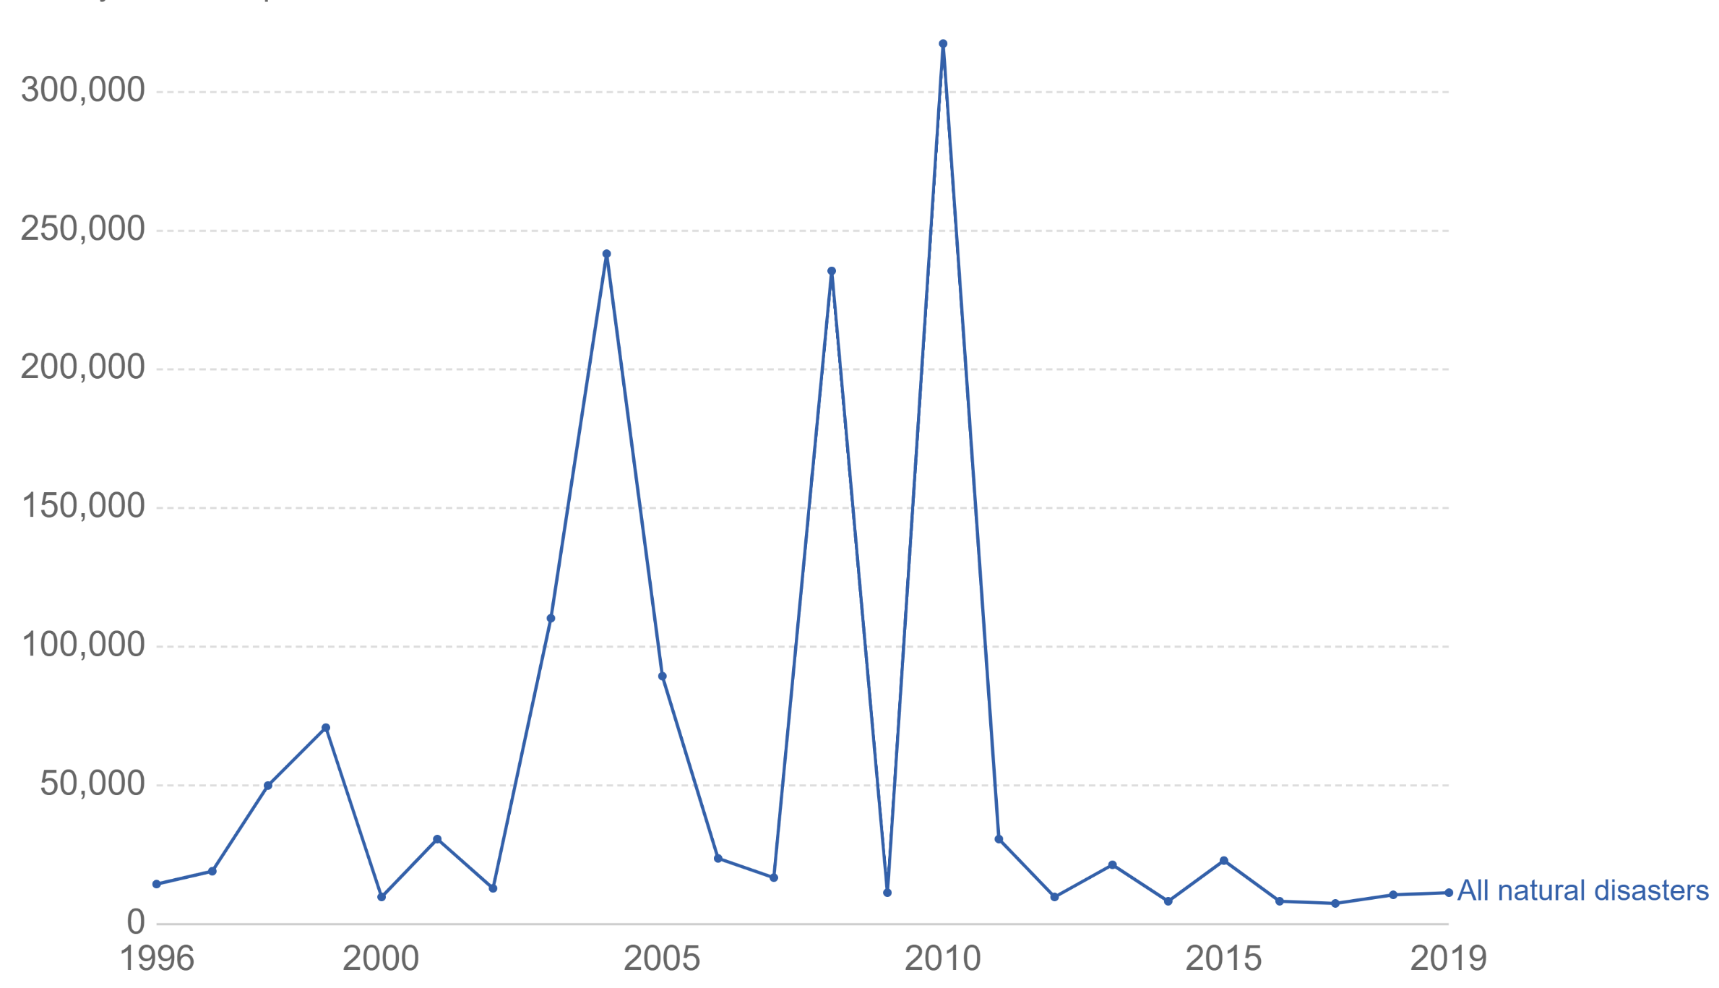

**Figure 4: Global deaths from natural disasters** **[8]**

**1.1.2 Project Goals**

Technological advancements in the field of satellite image detection can play an important role in knowing the impact of the disaster.Without technology, it was difficult to coordinate and assess the impact of a natural disaster. Collecting the post disaster data is difficult and dangerous, as it requires masses on the ground to assess damage during or after a disaster. This manual process for assessing impact is time and effort consuming leading to fallacious results. Improper planning to conduct relief operations affects disaster management practices. It is also vital to identify the disaster affected areas such that the development can be started. Keeping in mind those drawbacks, advancements in technology motivated to develop a framework that will help humanity to measure and monitor the impact of disaster on buildings by using data science tools and techniques. Quantifying the impact will convey better results to solve the problem stated.

The goal of this project is to develop an integrated framework for natural disaster management with the use of pre and post-disaster satellite images. We will locate areas of maximal disaster damage by using buildings as a reference and detect the change in the features of buildings using image annotation, before and after the disaster which will enable us to determine areas where to focus the relief efforts. After occurrence of a disaster, knowing the extent of damaged buildings over a large affected area will help in emergency actions and rescue works. Quantifying the impact of a disaster by defining an index will help in fulfillment of the gap between the disaster and development. This will result in speedy recovery of monetary or financial loss occurred due to damage. It will be easy to connect with local partners and relief organizations to request adequate resources like medical services, shelter, food, clothing, transportation and communication by knowing the disaster impact and damage intensity.

**1.1.3 Composite Design**

We will be proposing a model that will predict the building damage occurred during a disaster. Given a pair of pre and post disaster images, our model will detect and classify the building damage. Input images are square RGB image in PNG format, with height and width of 1024 pixels each. Pre/post images are identified by matching numerical IDs for each set of pre/post filenames. Predicted output will be a pair of PNG images, one for detection and the other for assessing damage, where each pixel value corresponds to the predicted class at that point in the input image. Each output image will have height and width of 1024 pixels (same dimensions as the input images). For building detection, predicted pixel values will be 0 (No Building) or 1/non-zero (Building). For damage assessment, predicted pixel values will be in the range 0 - 3: 0 - no damage; 1 - minor damage; 2 - major damage; 3 - severe damage.

The neural network models, ResNet and U-Net will be based on CNN architecture which can be used in parallel as components. Our Model will include both a network pre-trained on ImageNet and an initially untrained network. These two networks function as simultaneous feature extractors, and we will combine their features by concatenating their outputs and feeding the result to a network of several dense layers.

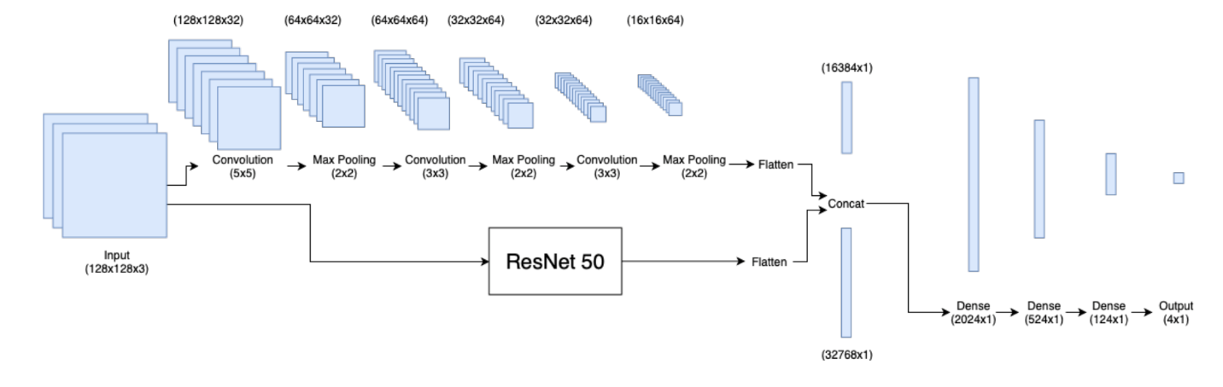

**Figure 5: Architecture of the baseline classification model**

## 1.2 Analysis of Requirements

**1.2.1 Business Objective**

Pre and post-disaster satellite image analysis derived from satellite imagery sources can support decision making and situation awareness during the phases of the disaster and crisis cycle. This can be defined through rapid analysis, preparedness, alertness, response, recovery and reconstruction. During the response, recovery and analysis phase, very fast delivery of up-to-date, accurate and comprehensive satellite image analysis models can significantly help in the assessment of large disaster situations. Satellite image analysis techniques based on machine learning and deep learning models can be utilized for prioritizing of rescue efforts. Inspired by this satellite imagery analysis technique, our model utilizes satellite imagery data to recognize the impacted buildings and produce a metric which will enable us to determine zones, where to focus the relief and rescue efforts. This model can help civil protection, humanitarian relief workers, donor/funding organizations, and many more. Figure 6 illustrates a natural disaster scenario and a use case for our business objective.

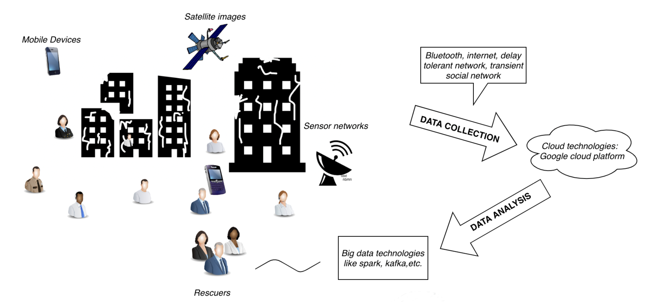

**Figure 6: Natural Disaster Scenario**

**1.2.2 Technical Objective**

The technical analysis of the project counts for the software technology. In our project the technical feasibility is considered by using Python language. It has a rich collection of libraries which are used for data cleansing, data validation, data transformation, training data, modelling and evaluation. After following the proposed architecture as shown in Figure 7, the dataset will be evaluated using F1 score, confusion matrix and classification report as the metric.

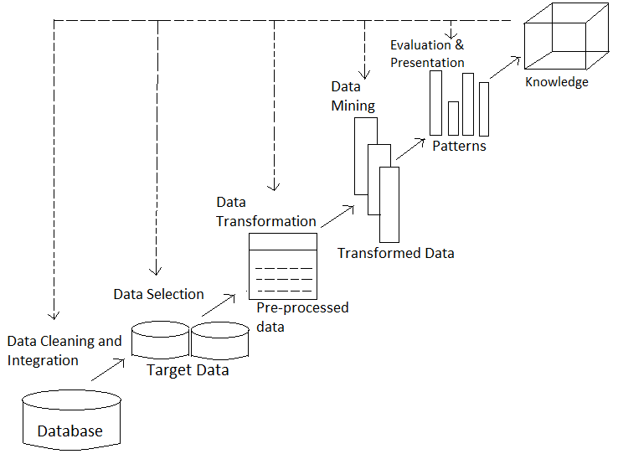

**Figure 7: Proposed Architecture**

The functional, non-functional and operational requirements of the system which describes the user’s interaction with the system are:

**Functional Requirements -** It describes the components of system, inputs, behavior and output.

* **Input -** Pre and post disaster satellite images.
* **Output -** Greyscale PNG Image classifying building damage post disaster

**Non-functional Requirements -** The qualities of the system are:

* **Usability -** The users get image within minutes which can save a lot of time, effort and help in recovery planning.
* **Interface -** The Interface designed aims at providing a flexible front-end communication to the user such that clear information is available while navigating the system.
* **Supportability and Portability -** The system designed is supportable cross-platform.

**Operational Requirements -** Operational feasibility is also known as Behavioral feasibility, as it measures the behavior of users i.e. how efficiently the application is used by users. The application is behaviorally feasible as it is easy to operate online, accurate and fast.

1.2.3 **Data Challenges**

Dataset for damage assessment is hard to obtain. Although the natural disaster brings catastrophic damage, they are relatively infrequent, so the availability of related satellite imagery is less. Furthermore, building designs and structures differs depending upon where it is located in the world. As a result, damage of the same intensity can look different from place to place. So, the data must exist to reflect this problem.

Detecting destruction of buildings through satellite images can also be a tough task. Environmental factors like smoke and fog in satellite images make it difficult to assess the damage impact. Obtaining and analyzing the building satellite images from publicly available sources such as www.xview.org [9] and www.planet.com [10] to detect the disaster depends on the quality of the raw satellite images and high computational power. The metric to estimate the impact of the destruction based on satellite imagery needs to be bias-free. It not only requires a significant difference in the pre and post image pixels but also that the model classifies this difference correctly.

## 1.3 Project Deliverables

Project deliverables are the possible outcomes of the project completed with given resources and time. The deliverables for the project following the data science life cycle is shown in Table 1.

**Table 1: Data Science Life Cycle**

|  |  |  |  |
| --- | --- | --- | --- |
| **Milestone** | **Task** | **Subtask** | **Deliverables/Checkpoint** |
| **Business Understanding** | **Team Formation** | Deciding number of people in a team identifying stakeholders. | Project Abstract  (Documentation) |
| **Topic Selection and Details** | Identifying Problem Statement  Determining Goals and Objective.  Defining criteria of success. |
| **Requirement**  **Specification** | Analysis of Requirements | Draft Project Report (Documentation) |
| **Data Understanding** | **Data Collection** | Obtaining access to data available publicly/privately  Exploring data | Draft Project Report (Documentation) |
| **Data Preparation** | **Data Cleansing** | Cleaning data | Draft Project Report (Documentation) and Jupyter Notebook |
| **Data Filtering and Validation** | Filtering and Validating data required for the proposed framework |
| **Data Transformation** | Feature selection and transformation for applying deep learning model | Draft Project Report (Documentation) and Jupyter Notebook on HPC Server |
| **Modeling** | **Data Modeling** | Selecting and building machine learning/deep learning model | Final Project Report (Documentation) and Jupyter Notebook on HPC Server |
| **Evaluation** | **Model Evaluation** | Measuring the accuracy of the results derived from model selected | Final Project Report (Documentation) and Jupyter Notebook |
| **Deployment** | **Model Deployment** | Deploying Model  Monitoring and maintaining model | Final Project report (Documentation), Jupyter Notebook, deployment on local host. |

## 1.4 Technology Trends and Solution Survey

Deep learning is the emerging technology for performing classification tasks directly from images, text and sound. It is majorly used because of achieving better accuracy, which was not possible before. Some of the technology trends are shown in Table 2.

**Table 2: Technology Trends and Solution Survey**

|  |  |  |  |
| --- | --- | --- | --- |
| **Reference** | **Data Collection** | **Technologies Used** | **Input Description** |
| [11] | Unmanned Aerial Vehicle (UAV)- Satellite spacecraft | DeepEye structure- UAV based rapid mapping system.  Combination of Convolutional Neural Network (CNN) and Markov Random Field (MRF) models. | Combination of spectral (RGB images) and (Geometrical Surface Models). |
| [12] | Strong motion data of seismic network archives to calculate earthquake waveforms | Long short-term memory networks (LSTM) | Based on sequence of data. |
| [13] | Pre event and post event satellite images | Adaptive Network based Fuzzy Inference System (ANFIS) spectral, textural, transformed. | High spatial resolution images. |
| [14] | Internet of Things (IoT) based sensor. | IoT integrated with deep learning.  Generative Adversarial Network (GAN) can be used to create data for training and testing if the sensed data output is insufficient. | Sensed data in the form of images. |
| [15] | Remote sensing imagery- Aerial images | Convolutional Neural Network (CNN) with imagery segmentation (Object oriented). | Image patches and segmentation. |
| [16] | Seismic data from seismograms | Convolutional Neural Network (CNN) ConvnetQuake | Single waveform |

## 1.5 Literature Survey of Existing Research

Several research works are conducted and published in the field of natural disaster management. Different deep learning models help in achieving the desired objective. Different Convolutional Neural Networks are used for image classification and object detection purposes. The comparison of research work conducted in disaster management are shown in Table 3.

**Table 3: Comparison of research work conducted in disaster management**

|  |  |  |  |  |
| --- | --- | --- | --- | --- |
| **Paper No.** | **Area/Aim of Study** | **Parameters/Features extracted** | **Model/Method Implemented** | **Model Evaluation/ Results** |
| [17] | The aim of this paper is to assess if the combined use of different resolution images improves the image classification of building damages from satellite images using CNN. | Buildings | A CNN framework using residual connections and dilated convolutions | The accuracy of the satellite image of building damages was improved by 4 % by using different resolutions and combinations in the train data of CNN. |
| [18] | It proposes a general solution for disaster management activities in smart cities. | Buildings, Water | Big Data Analytics, IoT devices, Cloud Computing | A layered architecture for moving towards managing disaster |
| [19] | It aims to assessing damage to buildings using only post-disaster image data. Using neural networks to obtain continuous damage severity. | Buildings, walls and ceiling | Three different pipelines for preprocessing data, extracting deep features from an input source and each pipeline is made up of one or two different Convolution Networks. | Color masking of relevant objects and features from raw input performs better than other models. |
| [20] | They proposed a damage mapping framework that uses a deep learning algorithm for classifying the damage into ‘washed away’, ‘collapsed’ and ‘survived’. | Buildings | U-Net convolutional network-  25 epochs for both the U-Net model and deep residual U-Net to obtain the trained damage recognition model. | Deep residual U-Net model overall accuracy is 54.8% while for U-Net Model Overall Accuracy achieved 70.9%. |
| [21] | Based on building footprint map from very high-resolution post-event SAR image. The machine learning classifiers were used to identify standing and collapsed buildings. | Buildings | Random forest (RF), support vector machine (SVM) and K-nearest neighbor (K-NN) | TerraSAR-X ST data are used for building  damage assessment.80% above accuracy with all the three classifiers is achieved. |
| [22] | The performance of conventional methods and Convolutional Neural network with random forest is used to detect building damage. | Buildings | Convolutional Neural Networks are used with Random forest. | Overall Accuracy of 87.6% is achieved when CNN is used with random forest method. |

# 

# 2. DATA EXPLORATION

## 2.1 Data Exploration Strategy and Planning

We obtained the data from xview2 website [9] for six different types of natural disasters around the world, covering a total area of over 45,361 square kilometers. Our dataset of 850,736 buildings has building polygons, classification labels for damage types, ordinal labels of damage level, and corresponding satellite metadata. The overall model pipeline will be as below in Figure 8:

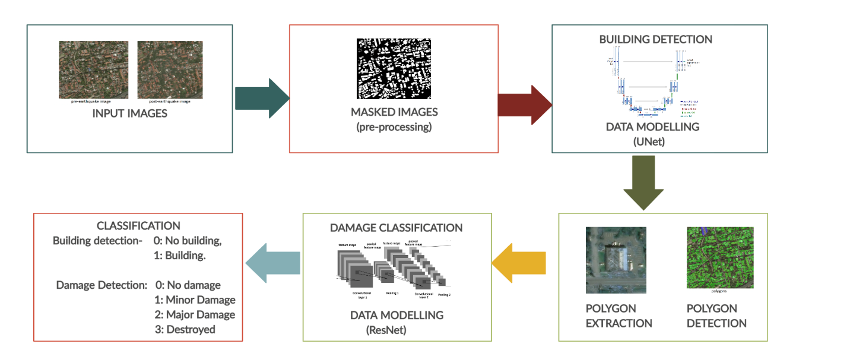

**Figure 8: Model Pipeline**

The neural network models, ResNet and U-Net with activation function ReLu, based on CNN architecture are used in parallel as components. Our Model will include both a network pre-trained on ImageNet and an initially untrained network. These two networks function as simultaneous feature extractors, and we will combine their features by concatenating their outputs and feeding the result to a network of several dense layers. [23]

Image annotation technique will be used for labeling the images with certain outliers and keywords to make it machine recognizable. The annotation process will lead to creation of polygons and damage classification. Dataset images consist of buildings as lists of vertex coordinates. In the first phase of data processing, we will convert these lists of vertices into categorical masks. Validation split will be performed after image masking process.

We are also going to use a self-defined metric where we will calculate the proportion of damaged buildings over the sum of damaged and non-damaged buildings.

$$Disaster Index=\frac{c1\left(N\left(L=2\right)\right)+c2\left(N\left(L=3\right)\right)+c3\left(N\left(L=4\right)\right)}{\sum_{i=1}^{i=4}{N\left(L=i\right)}}$$

Where:

c1,c2 and c3 : coefficients, 1 >= c3 > c2 > c1

L=i: Intensity of the disaster

N(L=i): Number of buildings with disaster label i

For example, let us assume that the total number of buildings are 10. The number of buildings classified as minor damaged, major damaged and destroyed are 6, 3 and 1 respectively; and the values of c1, c2 and c3 are 0.2, 0.3 and 0.5 respectively. In this case, our metric would result in $Disaster Index=\frac{0.2*6+0.3*3+0.5*1}{10}$ = 0.26, showing a 26% damage in the area.

The above metric can be used to quantify the impact of the damage that occurred by a disaster in that region. This metric is achieved by calculating the ratio of damaged buildings and the total number of buildings in the region. As data consists of levels of damage over a building, weights are used with respect to the severity of damage to calculate the damage index. The three levels of damage observed are 2, 3 and 4. Each level is quantified with corresponding weights c1, c2 and c3, where c3 > c2 > c1.

Another metric, Joint Damage Scale (JDS) will be used for scoring and evaluation [24]. Each pixel is annotated on a scale from 0 to 3 as shown in Table 4.

**Table 4: Damage Scale**

|  |  |
| --- | --- |
| **Scale** | **Label** |
| **0 (No Damage)** | Building detected, but no damage took place. |
| **1 (Minor Damage)** | Building partially burnt, roof element missing, or partial cracks. |
| **2 (Major Damage)** | Wall or roof collapse, encroaching volcanic flow nearby, or surrounded by water/ mud. |
| **3 (Completely Destroyed)** | Scorched, completely collapsed, or no longer present. |

## 

## 2.2 Data Sources and Dataset Parameters

Data is sourced from xview2 website. They have used imagery from Digital Globe’s Open Data Program and Maxar.The dataset has images in PNG and three-band RGB format.Data related to metadata of images is in JSON label files. These JSON files is converted into pandas data frame as shown in Figure 9.

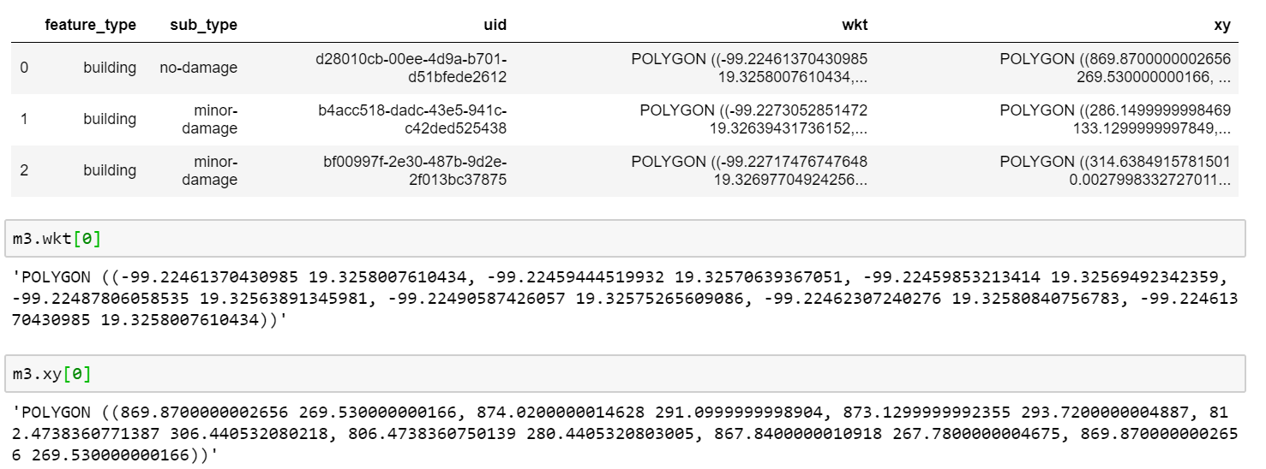

**Figure 9: Data Frame view of the Feature Properties**

The description of fields in metadata is explained in Table 5.

**Table 5: Feature Description**

|  |  |
| --- | --- |
| **Labels** | **Description** |
| capture_date | The timestamp on which the image was captured by satellite. |
| disaster | Describes the disaster name |
| disaster_type | Describes the type of disaster |
| height | Height of the image in pixels. |
| width | Width of the image in pixels. |
| img_name | Parameter describing the png image related to json file. |
| sun_azimuth | It’s an angle of the sun’s position relative to local horizon. |
| sun_elevation | It’s an angle of the sun relative to the Earth’s horizon. |
| target_azimuth | Satellite sensor angle measured from true north to the projection of sensor perpendicular to the Earth’s horizon |
| lng_lat: feature_type | The type of feature or object instance in the image. |
| lng_lat: sub_type | Describes the category of damage related to an object (No Damage, Minor Damage, Major damage, Destroyed) |
| lng_lat: wkt | Describes the different vertices of the object instance. Each vertex is a representative of longitude and latitude. |
| xy | Describe the similar content as _lat but the latitude and longitude are transformed to pixel positions X and Y. |
| sensor | The satellite from which image was collected |
| gsd | Ground sample distance |
| off_nadir_angle | Angle at which satellite sensor captures the image. |
| pan_resolution | Pansharpened image |
| catalog_id | The catid that this image corresponds to in DigitalGlobe’s database |
| original_width | Width of the image as annotated by the labelling process (Pixel) |
| original_height | Height of the image as annotated by the labelling process (Pixel) |
| id | A unique identifier assigned to each image |
| img_name | Name assigned to the image during labeling process |

Few values of the metadata description using pandas dataframe are shown in Figure 10.

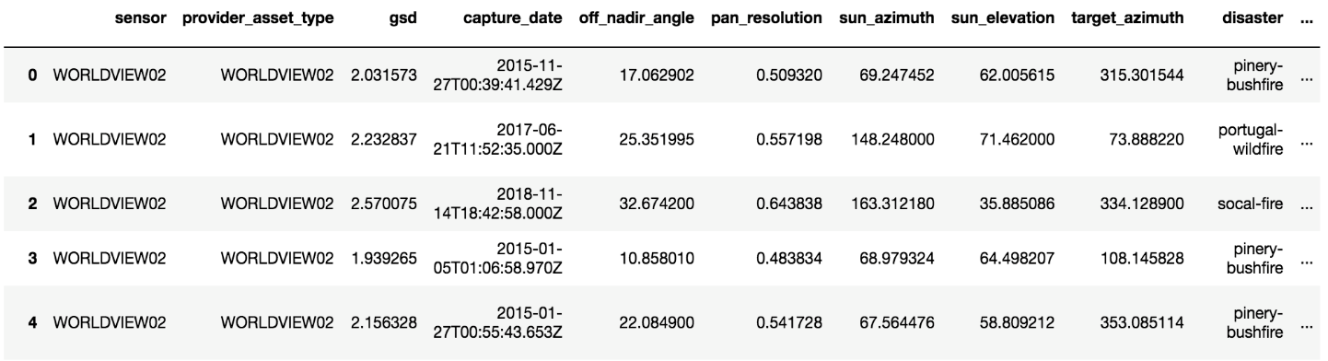

**Figure 10: Metadata values using python**

Few properties of the metadata using pandas dataframe are shown in Figure 11.

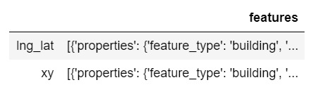

**Figure 11: Metadata values using python**

## 2.3 Collection of Training Datasets

Data is collected in the form of images captured from satellites by several organizations and made available publicly. Satellite images are a vital source of information and contain more structured and uniform data as compared to traditional images. These high-resolution images are annotated polygons having 5 pairs of coordinates (longitude and latitude) for each building. This information is contained as labels in the training data having pre and post disaster images and labels. The labels data is in the form of JSON (JavaScript Object Notation) data. The original images in dataset are shown in Figure 12:

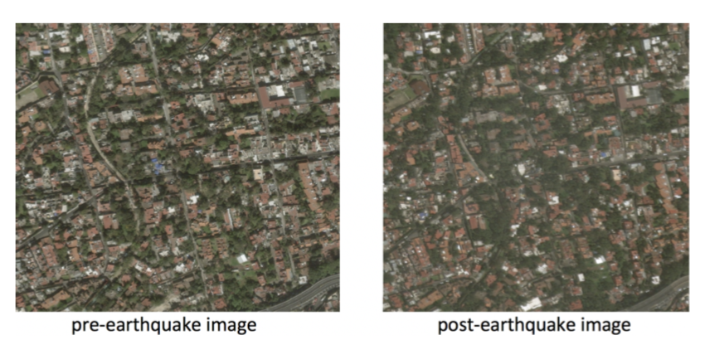

**Figure 12: Sample pre/post Mexico earthquake disaster image**

The initial count of images in dataset is shown in Table 6.

**Table 6: Count of train/test images in dataset**

|  |  |
| --- | --- |
| **Images** | **Count** |
| Train | 14670 |
| Test | 3667 |

The dataset will be split into train-test in the ratio of 80% and 20% respectively. The hyperparameters which will be used while training is:

* Optimizer
* Learning Rate
* Data Augmentation
* Activation Function
* Batch Size
* Loss Function
* Number of Epochs

## 2.4 Data Cleansing and Validation

We will be extracting the data related to earthquakes, floods, tsunamis, volcanoes, wind and wildfires from the various disasters available in the data. Data images are square RGB (Red, Green, Blue) image files in Portable Network Graphics (PNG) format, with height and width of 1024 pixels. Pre/post pairs will be identified by matching numerical IDs for each set of pre/post filenames using the Pandas python library. Each image consists of metadata (off-nadir) which will allow data processing pipelines to be used. The dataset consists of the following:

* Building polygons, which are granular representations of a building footprint.
* Ordinal regression labels, rate how damaged a building is on an increasing integer scale.
* Multi-class labels relate all the environmental factors that caused damage seen in the image.
* Environmental factor bounding boxes and labels, which are a rough approximation of the area covered by fire, smoke, water, and other environmental factors.

The data provided is a precleaned dataset. The dataset also has columns and filenames with disaster types with values such as earthquake, fire, hurricane and volcanoes; and disaster column has location-specific disasters like mexico-earthquake and socal-fire, from which natural disasters relevant for study can be filtered as shown in Figure 13.

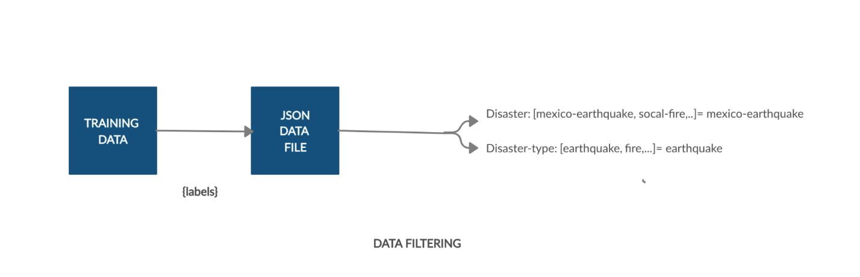

**Figure 13: Data Filtering**

The following steps will be followed for cleaning and validating the data:

* Check if every image has a corresponding JSON file available in the train dataset. The images that do not have the JSON file will be removed train dataset. Every JSON file has parameter img_name which tells the name of the corresponding image file. Using Python, we will check if the image file exists in the directory based on the img_name parameter from each JSON file.
* Check for any duplication and mix-up of images in the pre-disaster and post-disaster dataset. This can be verified using the Capture_date parameter in the JSON files. Those images can be arranged in the related datasets.
* Verify that for every pre-disaster image, there is a corresponding post disaster image in the training dataset.
* Check if all the images have the same height and width using Python Imaging Library (PIL), as required for implementing a deep learning model.
* Check if there are any irrelevant classification labels other than the expected classification labels (No Damage, Minor Damage, Major damage, Destroyed) from the feature Lng_lat: sub_type in our dataset.
* Check the feature {Lng_lat: wkt}, which denotes the latitude and longitude of the building, is in the range of (+15 and +33) and (-120 and -85) respectively as these are the longitude and latitude bounds of particular region. For example, our dataset consists of an earthquake from Mexico, we expect the location of the impacted building within the coordinates of Mexico.
* Check for the presence of irrelevant images by comparing pixel values in python. For example, images with cloud cover can be excluded as those images could lead to a biased result.

## 2.5 Data Transformation and Tools

Feature selection will involve selecting relevant features to be used for model training. We will extract features like disaster, disaster_type, height, width, img_name, lng_lat (feature_type, wkt, uid, subtype) from JSON files in train data and transforming them into a data frame using Pandas library in Python. The dataset defines buildings as lists of vertex coordinates. In the first phase of preprocessing, we have converted these lists of vertices into categorical masks. We assumed “undamaged” class for the buildings with no explicit damage.

The properties in the lng_lat feature will be vectorized. The subtype values will be converted to binary values classifying as damaged (1) or undamaged (0). After standardizing the features as stated above, image data will be processed using the masking technique by which vector labels are converted into pixel masks that are compatible with Machine Learning using Python libraries. An example is shown below in Figure 14.

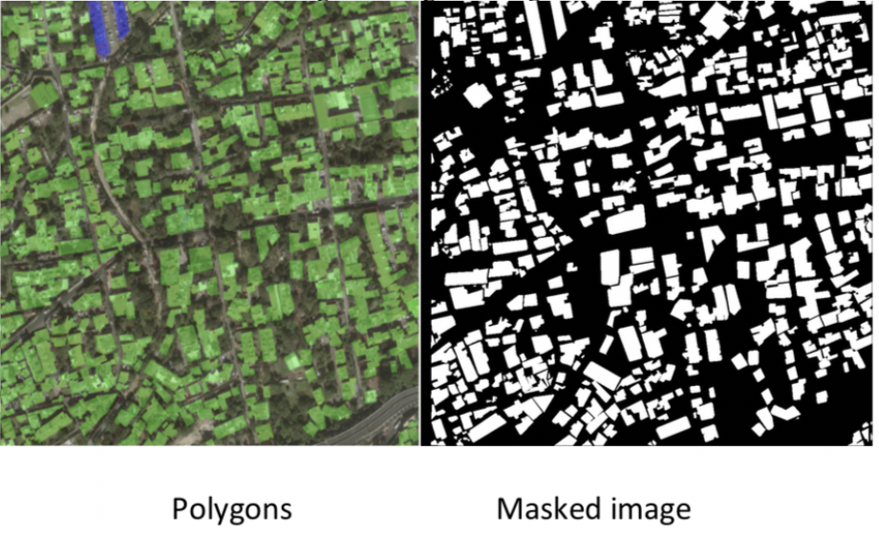

**Figure 14: Polygons and Masked images**

Following the mask generation, we will perform a validation split. Because of the relatively small number of training images, we will only set aside 20% of the data as validation data.

The Major Python Libraries used are explained in Table 7 – tensorflow-gpu, geopandas, shapely, tqdm, imgaug, opencv and matplotlib.

Major tools we will use are explained in Table 8 - Jupyter Notebook, SJSU - High Performance Computing (HPC), CUDA, PyCharm IDE, Tableau, Power BI and Creatly.

**Table 7: Major Python libraries Used**

|  |  |
| --- | --- |
| **Package Name** | **Package Description** |
| GeoPandas | To work easily on geospatial data in python. |
| Shapely | Used for manipulation and analysis of planar geometric objects. |
| tqdm | Used for creating progress bars with python. |
| imgaug | Library for image augmentation. |
| OpenCV | It is a video and image processing library bound in python. |
| matplotlib | Library for creating static, and interactive visualizations in python. |
| chainer | Flexible, powerful deep learning network |
| libtiff | Library for reading and writing tagged image file format |
| Tensorflow-gpu | Opensource library for high performance numerical computation. |
| Pillow | Image processing library forked from python image library. |

**Table 8: Major Tools Used**

|  |  |
| --- | --- |
| **Tools Used** | **Description** |
| SJSU- High performance computing | Computing system providing powerful servers, storage and memory. |
| PyCharm | Python IDE for development in python. |
| Tableau, PowerBI, Zoho analytics | IDE used for visualizing the data. |
| Creately | A tool used for creating flowcharts. |
| CUDA | Computing platform for GPU |

## 2.6 Raw Data Visualization

For communicating both abstract and concrete ideas, graphical visualization is one of the effective means. The xBD dataset has 15 countries and 6 types of disasters as shown in Figure 15.

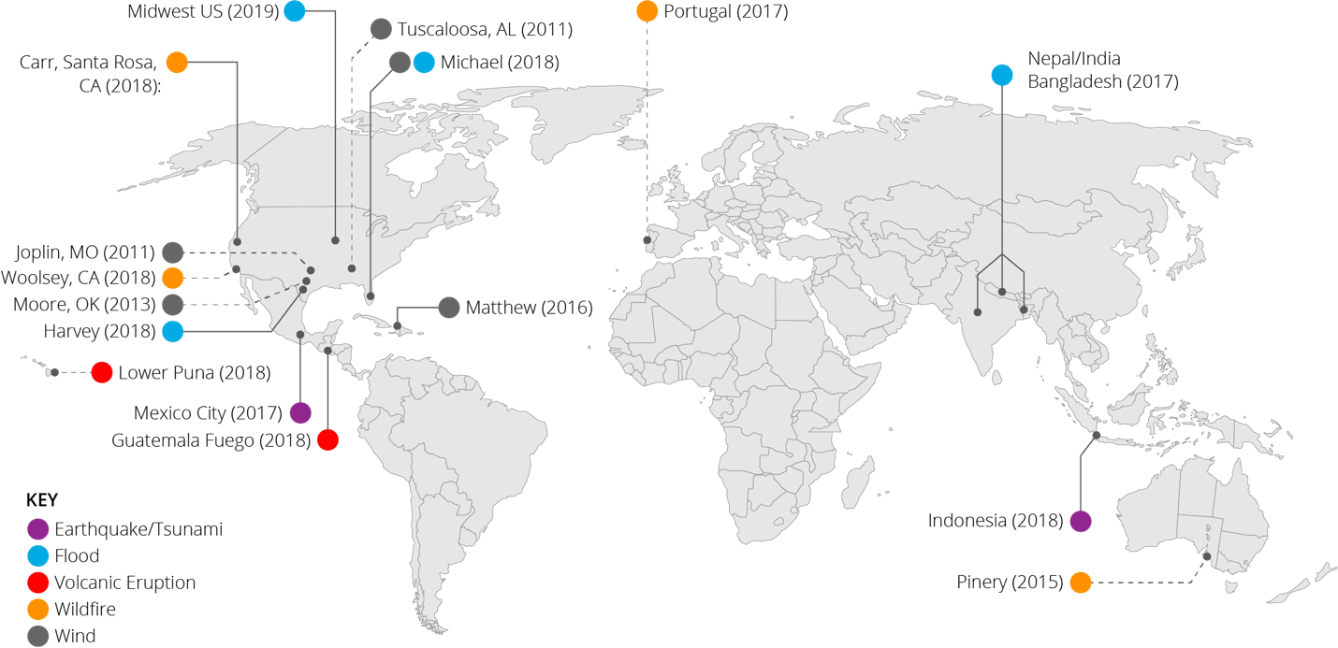

**Figure 15: Geographical representation of data**

On exploring the dataset using python libraries it is observed that 15 countries and 6 types of disasters are included in the dataset as shown in Figure 16 and Figure 17. It also shows that Portugal-wildfire and pinery-bushfire has largest number of images and Guatemala-volcano has least number of images. This ensures that abundant training data is available in the dataset.

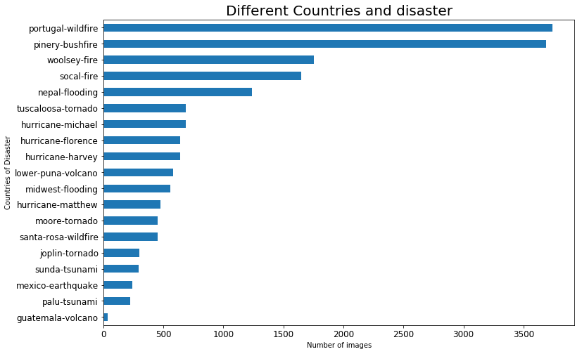

**Figure 16: Different countries and disasters**

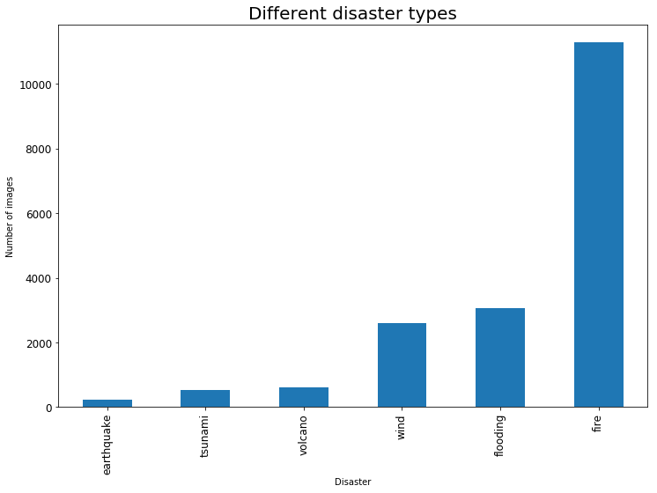

**Figure 17: Different types of disasters**

Ground Sampling Distance (GSD) is one of the important metadata columns. The spatial resolution of a sensor is defined by a measure GSD or pixel size. If the GSD is specified too high (high GSD means small pixel size on the ground, for example 5 cm) more flight lines will be required and the amount of data per area will increase. It has impact on data processing cost as well. Standardization of GSD across dataset may help in achieving better results while training in neural network. [24] The Figure 18 shows mean GSD values per disaster image.

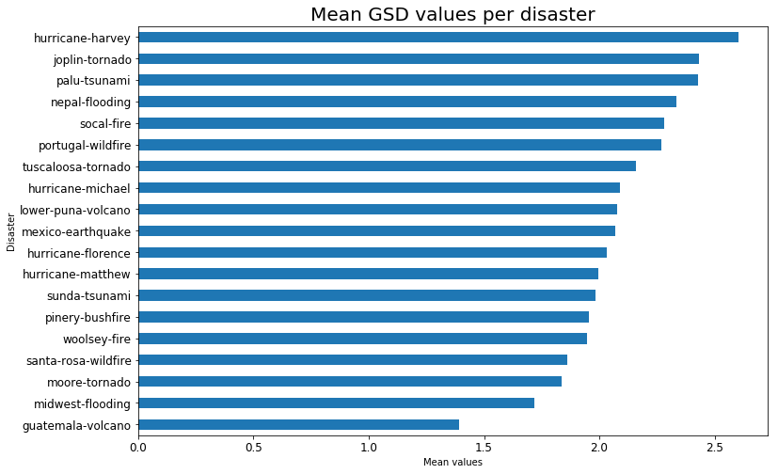

**Figure 18: Mean GSD values per disaster**

The Guatemala - volcano has the lowest GSD which makes its imagery to be more detailed and closer to the ground. If super-resolution techniques can be used, then the other images can also be brought at this GSD level. Thus, neural net can be trained at a standard level.

Different satellites owned by DigitalGlobe and Maxar are used for capturing images. In this dataset, maximum images are captured by worldview02 satellite. This satellite can collect high-resolution images, 8-band multi-spectral images and covering upto one million square kilometers of 8-band imagery per day. Other satellites are QUICKBIRD02, GEOEYE01, WORLDVIEW03_VNIR. Figure 19 represents the same.

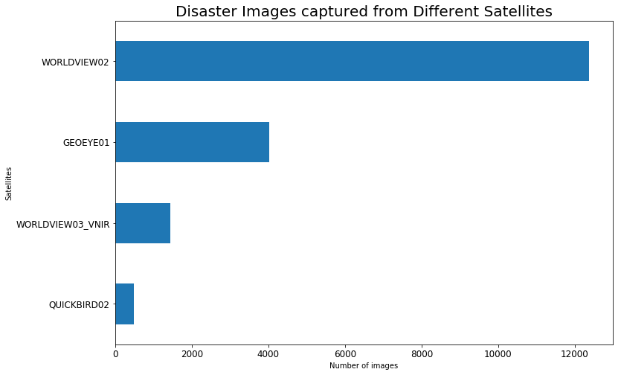

**Figure 19: Different satellites used for capturing images**

# 3. PROJECT MANAGEMENT

To understand the exact goals of the project, how can they be achieved by managing people (Project Organization), resources (Resource Requirements), timelines (Project Schedule) and applying knowledge, tools and skills is the practice of Project Management. [25]

## 3.1 Project Organization

A Project Organization is a structure defining the team hierarchy as shown in Figure 20.

**Project Committee**

Dr. Lee Chang Graduate/Academic Advisor

Dr. Simon Shim Technical Advisor

**Figure 20: Project Hierarchy**

**Project Team Members**

Ippili, Amar

Johri, Shubh

Nadathur, Aarathi

Puraswani, Divya

Rajput, Sameer

The Data Science model used for planning, controlling and structuring the project lifecycle is CRISP-DM. It stands for the Cross-Industry Standard Process for Data Mining. It is an iterative process that is most widely used in the field of analytics. It is divided into six major phases as depicted in Figure 21:

* Business Understanding
* Data Understanding
* Data Preparation
* Modeling
* Evaluation
* Deployment

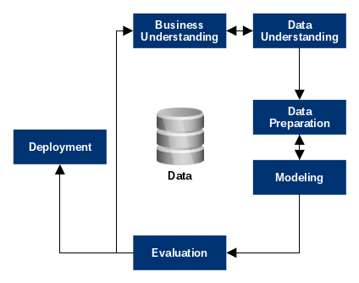

**Figure 21: Crisp-DM Process Model**

## 3.2 Resource requirements

We will implement the image annotation task using Fully Convolutional Net (FCN), TensorFlow library, Keras, along with other python libraries such as NumPy, SciPy, Pandas, shapely, tqdm, libtiff and OpenCV.

**Hardware Requirements**

Processor: 2.2 GHz Intel Core i7

Hard Disk: 256 GB

RAM: 16 GB

GPU: High performance computing (SJSU - HPC), CUDA

#### **Software Requirements**

Operating System: Windows/Mac

Python Notebook/IDE: Jupyter Notebook, PyCharm IDE

Python Libraries: OpenCv, Keras, Sklearn, NumPy, Matplotlib, Pandas, SciPy, TensorFlow, Shapely, Libtiff, Geopandas, Imantics, chainer, Pillow, imgaug.

## 3.3 Project Schedule

Project Schedule refers to the listing of tasks, deliverables and milestones within the project including its planned start and finish date. We have listed are tasks and deliverables using a PERT chart in Figure 22.

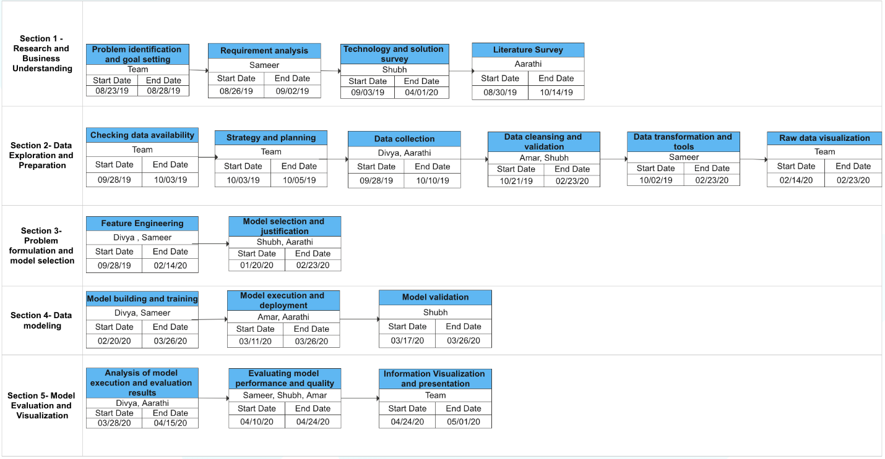

**Figure 22: Pert Chart**

# 4. PROBLEM FORMULATION AND MODEL SELECTION

## 4.1 Problem Formulation

Subjected to wide variety of natural disasters such as earthquakes, floods, hurricanes, and tsunamis, tangible assets such as land and buildings are prone to severe damage. These damages can result into an adverse effect on economy, infrastructure and human lives. For example, Table 9 shows severity and damages caused by earthquakes: [26]

**Table 9: Earthquake severity and damage**

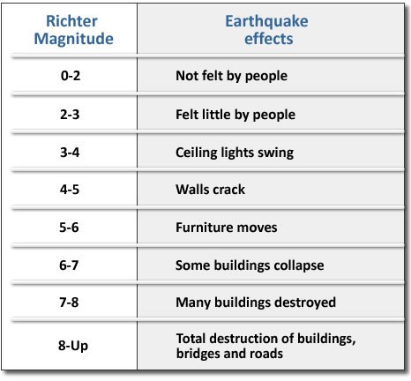

About 78% of deaths during earthquakes are caused due to structural collapses [27]. To keep number of people safe (physically, emotionally, mentally), minimal damage to infrastructure (buildings standing) and lifestyle, is the primary concern of people involved in emergency management during disaster. Knowing about which structures are operational by quantifying the impact will allow implementation of least mitigation measures during new construction. To assess the damage of these structures, satellite imagery is one of the effective means. Efforts of visiting physically to the affected area, manually filtering the images to assess the damage and sharing the same with the rescue teams makes disaster recovery efforts time consuming and slow.

The problem/challenge is to effectively and automate the task of assessing the impact of structural collapse (buildings) due to natural disaster such that people involved in emergency management like local governments, state governments, federal governments, nonprofit groups etc., can be informed and futuristic decisions can be made. Detecting the structural collapses on the ground and predicting the extent to which the damage has occurred would help in providing speedy recovery and relief efforts. The pre-labelled damage scale is shown in Table 10.

**Table 10: Pre labelled damage scale**

|  |  |  |  |
| --- | --- | --- | --- |
| **Disaster** | **Score** | **Label** | **Observed Structural Description** |
| **Earthquake** | 0 | No Damage | Building undisturbed |
| 1 | Minor Damage | Visible cracks on the building |
| 2 | Major Damage | Collapsed roof and cracked walls of building |
| 3 | Destroyed | Completely collapsed building |
| **Floods** | 0 | No Damage | No sign of water |
| 1 | Minor Damage | Structure surrounded by water |
| 2 | Major Damage | Major surrounding of structure with water |
| 3 | Destroyed | Building washed away by water |
| **Tsunami** | 0 | No Damage | No sign of water or mud |
| 1 | Minor Damage | Few visible water or mud signs |
| 2 | Major Damage | Building surrounded by water or mud |
| 3 | Destroyed | Building carried away by wind and washed by water |
| **Wildfires** | 0 | No Damage | No burn marks |
| 1 | Minor Damage | partial burnt building |
| 2 | Major Damage | Visible burn marks |
| 3 | Destroyed | Completely burnt / no longer present |
| **Volcanoes** | 0 | No Damage | Few marks |
| 1 | Minor Damage | Volcanic flow nearby |
| 2 | Major Damage | Covered with volcanic flow |
| 3 | Destroyed | Completely covered with lava |
| **Wind** | 0 | No Damage | Undisturbed |
| 1 | Minor Damage | Roof elements missing |
| 2 | Major Damage | Partial wall or roof collapse |
| 3 | Destroyed | Completely collapsed |

## 4.2 Foundation of Proposed Solutions

Building detection and damage assessment requires collection of relevant data. The dataset contains collection of pre and post disaster images related to several types of disasters from multiple locations. In order to solve the problem of manual filtration, the proposed solution follows data science lifecycle as shown in Figure 23.

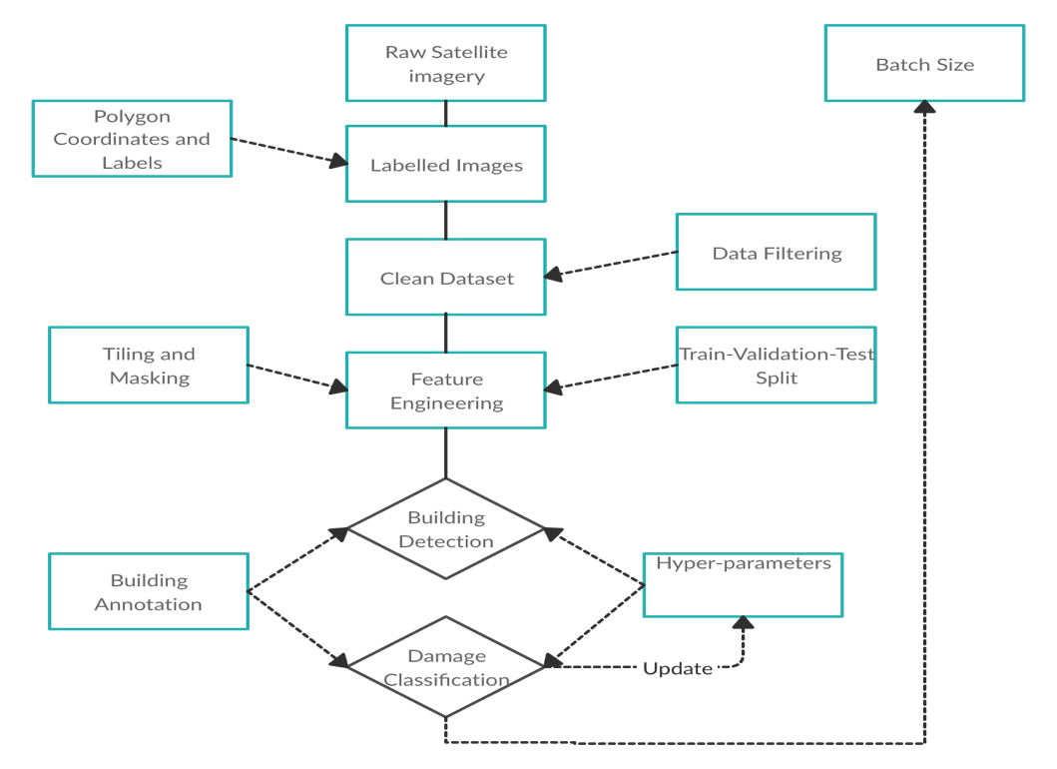

**Figure 23: Diagrammatic Flow of the proposed solution**

It detects the manually annotated polygons of buildings where 0 is no building detected and 1 detects the building along with the damage index scale ranging from 0 to 3. For Localization, the evaluation metric will be IoU, pixel accuracy and F1 score, as explained in Table 11.

**Table 11: Evaluation Metric for Localization**

|  |  |
| --- | --- |
| **Metric** | **Explanation of Metric** |
| IoU | Measure the accuracy of an object detected on a dataset |
| Pixel Accuracy | Measure percentage of pixels that are classified correctly |
| F1 Score | Represents the harmonic mean of precision and recall |

The classification will be computed by calculating the harmonic mean of the F1 scores for 0-3 classes. This scale for scoring and evaluation is called as Joint Damage Scale (JDS). [28]

In order to quantify the impact, weighted average is calculated. It is a self-defined metric. It is practical and basic method for contributing more to the “final value” of quantification. Therefore,

**Inputs will be:** A model will localize and classify building damage. Input images are square RGB image files in PNG format, having height and width of 1024 pixels. Pre/post pairs will be identified by matching numerical IDs for each set of pre/post filenames. For the training data, filenames include information about the disaster, but disaster information is unclear in the test dataset.

**Outputs will be:** Our model outputs a PNG image with height, width of 1024 pixels, where each pixel value corresponds to the predicted class in the input image as shown in Table 12.

**Table 12: Damage Classification Labels**

|  |  |  |
| --- | --- | --- |
| **Damage Label** | **Damage Level** | **Greyscale** |
| 0 | No Damage/Unclassified | Black |
| 1 | Minor Damage | Dark Grey |
| 2 | Major Damage | Light Grey |
| 3 | Destroyed | White |

At each pixel location, localization is scored against the polygons annotated in the "pre" images and damage classification is scored against the damage levels annotated in the "post" images.

## 4.3 Feature Engineering

It is the process of transforming raw data into features that represents the problem at hand to the machine learning predictive models, resulting in improved accuracy on unseen data. It is extracting relevant features and transforming them such that the better accuracy and results can be achieved.

The Feature Engineering for our problem is done in 2 steps:

1) Adding polygons to the building in the raw satellite image. Here, we have meta data for the polygons which consists of the pixel boundaries of the polygon.

2) Masking: Here, we are removing all the irrelevant features from the image by using a technique called Masking. The final image generated is an image where the relevant feature area is pixelated in yellow and the remaining area in black color. Figure 24 shows the sample output:

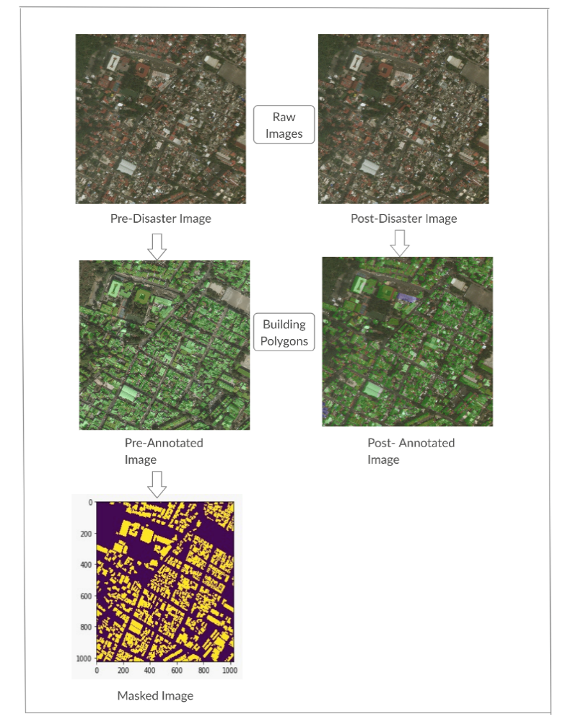

**Figure 24: Feature Engineering**

Our dataset is imbalanced, having majority of labels as 0 when compared to other labels (1-3). To handle imbalance in train and test dataset, before training the model we used random under sampling technique. This technique is used because of large size of imbalanced data. After exploring the data some of the irrelevant features which can be removed while training. Table 13 shows the irrelevant features of the dataset.

**Table 13: Irrelevant features of the dataset**

|  |  |
| --- | --- |
| **Labels** | **Description** |
| capture_date | The timestamp on which the image was captured by satellite. |
| disaster | Describes the disaster name |
| disaster_type | Describes the type of disaster |
| height | Height of the image in pixels. |
| width | Width of the image in pixels. |
| img_name | Parameter describing the png image related to json file. |
| sensor | The satellite from which image was collected |
| catalog_id | The catid that this image corresponds to in DigitalGlobe’s database |
| id | A unique identifier assigned to each image |

Some of the columns which might be relevant and required to be added are shown in Table 14.

**Table 14: Relevant columns to be added**

|  |  |
| --- | --- |
| **Labels** | **Description** |
| latlong | A geometrical point object with the latlong info. |
| label_path | Relative label path |
| no-damage | Count of class 1 polygons in the image |
| minor-damage | Count of class 2 polygons in the image |
| major-damage | Count of class 3 polygons in the image |
| destroyed | Count of class 4 polygons in the image |
| un-classified | Count of polygons with no classification |
| centroid_x | Combines polygon in image and fetch central coordinates (lat) |
| centroid_y | Combines polygon in image and fetch central coordinates (long) |

## 4.4 Select and Justify Solution Model

**Neural Network for image classification** -

For satellite image classification we have chosen Random forest, CNN and U-Net models. Neural networks are widely used for image classification and they provide better and accurate results. Techniques used in neural networks for image classification are:

1. **Segmentation in neural networks**

Dividing or partitioning the image into various parts called segments is called segmentation, which allows to make use of the essential segments for processing the image. Segmentation processes only the important segments of an image thus helping us focus on the problem in a more granular manner and get more accurate results.

1. **Region-Based Segmentation**

Region based CNN can address more complicated tasks, such as object detection and image segmentation, and it even becomes one important basis for both fields.

R-CNN achieves significant performance improvements due to highly discriminative CNN features.  CNN cannot process the whole image at once. It scans the image, looking at a small “filter” of several pixels each time until it has mapped the entire image.

1. **Edge Detection Segmentation**

Makes use of discontinuous local features of an image to detect edges and hence define a boundary of the object.

1. **Segmentation based on Clustering**

Creating homogeneous clusters by dividing the pixels of images. It works well on small datasets.

**Table 15: Comparison of image segmentation techniques**

|  |  |  |  |
| --- | --- | --- | --- |
| **Algorithm** | **Description** | **Advantages** | **Limitations** |
| **Region Based Segmentation** | Based on the threshold values, it separates the objects into different regions. | * Simple Calculations * Fast operational speed * Performs well with high contrast images. | Overlapping of grayscale pixels are hard to segment. |
| **Edge Detection Segmentation** | Makes use of discontinuous local features of an image to detect edges and hence define a boundary of the object. | Works better for high contrast between objects. | Not suitable if there is no contrast between objects in the image and too many edges in the image. |
| **Segmentation based on Clustering** | Divides the pixels of the image into homogeneous clusters. | Performs well with small datasets and generate excellent clusters. | * Computationally expensive and time consuming. * Not suitable for clustering non-convex clusters. |
| **Mask R-CNN** | Gives three outputs for each object in the image –   * its class * bounding box coordinates * object mask | * Simple, flexible and general approach. * Current state-of-art for image segmentation. | Very high training time. |

**Data Augmentation**

Data augmentation is a technique used to artificially expand the train data size by modifying the image data. To get more data, we can make minor alterations like flipping, rotating and scaling the images to our existing dataset, so that the neural network recognizes these as distinct images.

## 4.5 Justify Solution Model

**Table 16: Justification of models**

|  |  |  |  |
| --- | --- | --- | --- |
| **MODELS** | **U-Net** | **Random Forest** | **CNN** |
| **Overview** | * A basic U-net has a contracting path (down sampling) and an expansive path (up sampling). * The location information in contracting path and the contextual information from expansive path are combined to obtain a general information and is used to predict a better segmentation map. * The skip connections intend to provide local information to the global information while up-sampling. [29] | * Random forest is an ensemble model that uses the results from many different models to calculate a response. * In the case of random forests, several decision trees are created, and the response is calculated based on the outcome of all the decision trees. [30] | * **Convolutional Neural Networks (CNNs)** is the most popular neural network model being used for image classification problem. * CNNs use very little preprocessing as compared to other models. They can **learn** the filters that have to be manually specified in other algorithms. [31] |
| **Why this model?** | * U-net has the advantage of using images of different sizes as input as no dense layers are used. | * Random Forests provide great computational efficiency in both training and classification, their probabilistic output, the seamless handling of a large variety of visual features (e.g. color, texture, shape, depth) and the inherent feature sharing of a multi-class classifier. So, we can choose random forest for image classification. | * In CNN the number of parameters is independent of the size of the original image. * A CNN works by extracting features from images. This eliminates the need for manual feature extraction. |
| **Literature Survey** | * Used the U-net architecture for the earthquake damage detection. * Replaced ReLu with leaky ReLu activations in U-net improved accuracy and training speed. * The upfront padding is defined such that the network output has the same size as the unpadded. * The images where trained over on the Euler supercomputer (GeForce GTX 1080 GPU). The approaches used were:   (a) simultaneous and (b) separate training of localization and damage detection. | * In order to implement the RF two parameters, need to be set up: the number of trees (ntree) and the number of features in each split (mtry). * To find the optimal RF model for classification, a range of values for both parameters were tested and evaluated: ntree = 100, 200, 500, and 1000; mtry = 1:10 with a step size of 1. * Used Sentinel-2 with ten bands for classification, meaning the input data has 10 variables. | * In this the image detection is done using Convolutional Neural Networks (CNN) on satellite images which can then be threshold and clustered together into grids to find areas which have been most severely affected by a disaster. * A Disaster Impact Index metric is used to quantify the impact of two natural disasters - the Hurricane Harvey flood and the Santa Rosa fire. |
| **Results from Survey** | * The model worked well and could predict images for 0, 1 and 4 class and worked fairly for class 2 and 3. * Accuracies:   Combined- 0.491  Localization- 0.679  Damaged- 0.410 | * With the RF classifier, the larger training sample also produced higher accuracy with the first 4 sub-datasets (bset_1 to bset_4). * With the smallest training sample (bset_1), RF produced a higher accuracy (91.47%). * The stable accuracy results of bset_5, bset_6, and bset_7 (93.47%, 94.42%, 94.59%) were also observed with the RF classifier. | * The model gave a top F1 score of 81.2% on the gridded flood dataset and 83.5% on the gridded fire dataset |

# 5. MODEL DEVELOPMENT AND PRESENTATION

## 5.1 Model Building and Training

U-Net and ResNet deep learning models are used for achieving the desired objective of assessing and classifying the building damage. We utilized U-Net model for localization and ResNet model for damage classification. Localization refers to the process of estimating the location of object in an image. Therefore, in our case, U-Net model detects absence and presence of building as an object in an image in the form of 0 and 1 (0: no building, 1: building).

* **0: No building**
* **1: Building**

The damage classification problem is solved using ResNet as it attempts to classify damages with labels ranging from 0 to 3.

* **0: No damage building**
* **1: Building with minor damage**
* **2: Building with major damage**
* **3: Destroyed building**

The training dataset has pre- post disaster PNG images and corresponding labels in JSON format. We categorized data into various disaster types in structured format and split the data into disaster types with images and labels. The filtration of data was done using os and copy2 python libraries. The hierarchy for model training setup is represented below in the Figure 25.

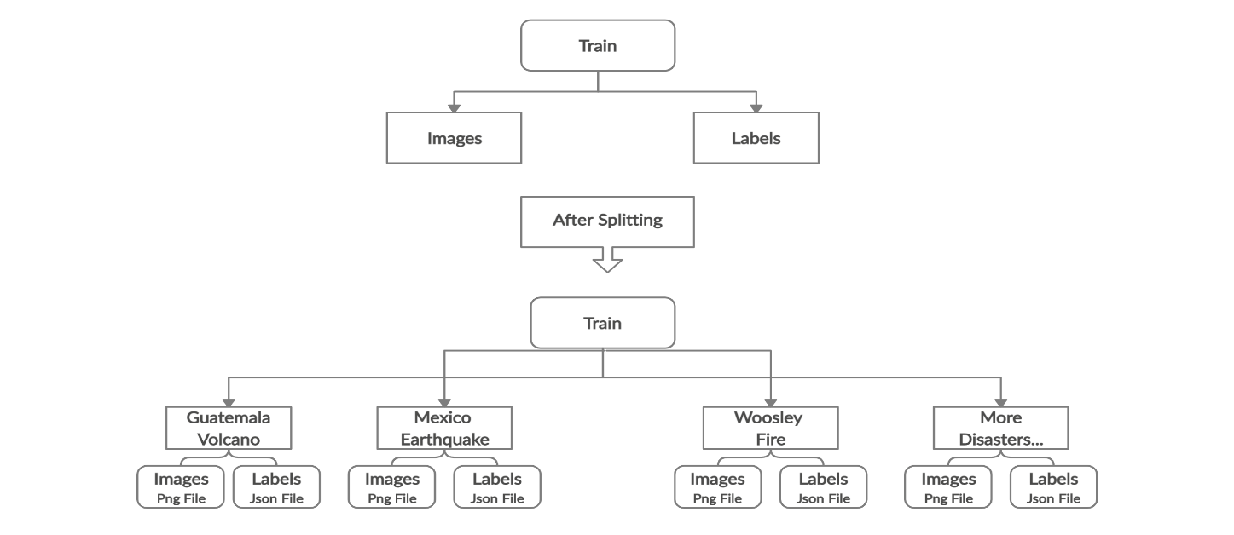

**Figure 25: Setting up the hierarchy for model training**

**5.1.1 Model Training for Building Localization**

Masking is an image preocessing technique which allows specific objects to highlight within an image by removing or blurring the background. The dataset consist of 18336 PNG files and corresponding JSON files which are given as input parameter for masking. The python package shapely is used to create polygons (geomteric object) to perform masking. WKT module provides loaders through which a separate mask is created for every feature in JSON. For each WKT polygon, format is read and filled as an image. Each polygon is stored in shapes as a numpy array, which then is created in a shapely polygon object. The center points of the polygon and the coordinate of the polygon are obtained to set a new polygon with each X andY coordinates, manipulated based on the center points. The numpy arrays are transferred back to polygons and the border is filled between closed polygons, so that the polygons can be differentiated. For each feature in the JSON, a separate mask is created. The output will generate masks folder having pre disaster masked images as shown in below screenshots.

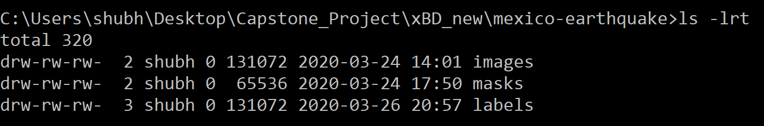

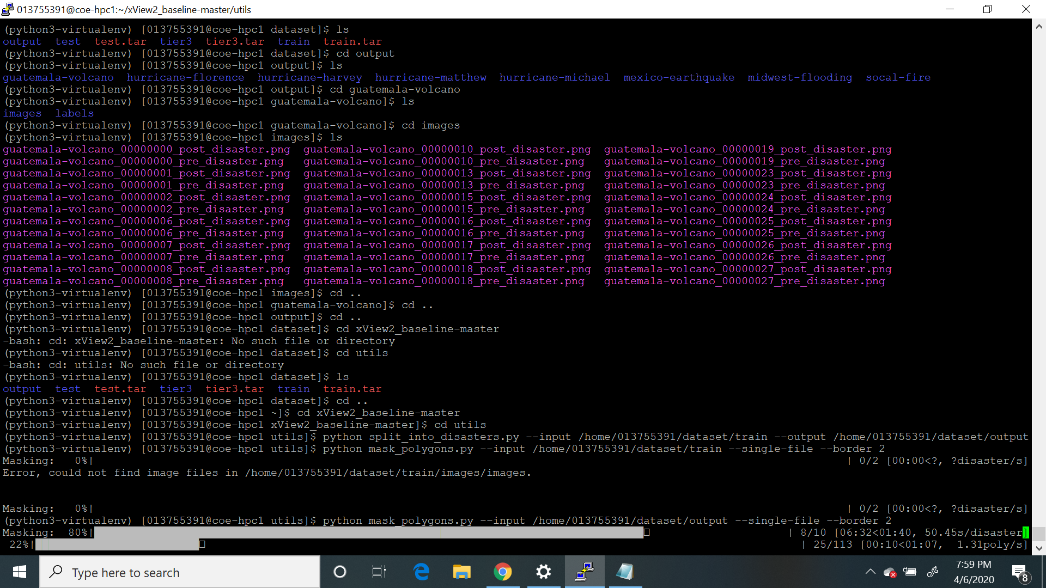

To detect the buidings, the masking is done for pre-disaster images. Figure 26 shows sample pre-disaster input image and corresponding masked image.

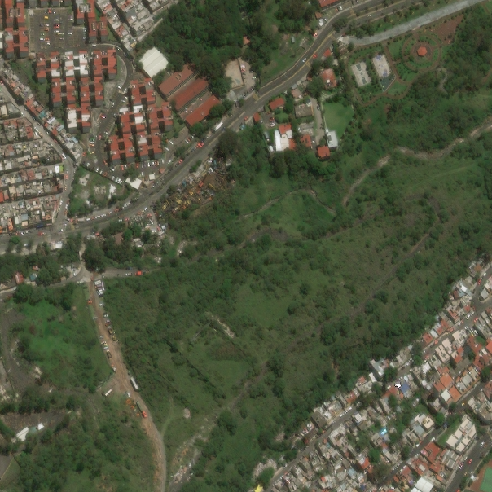 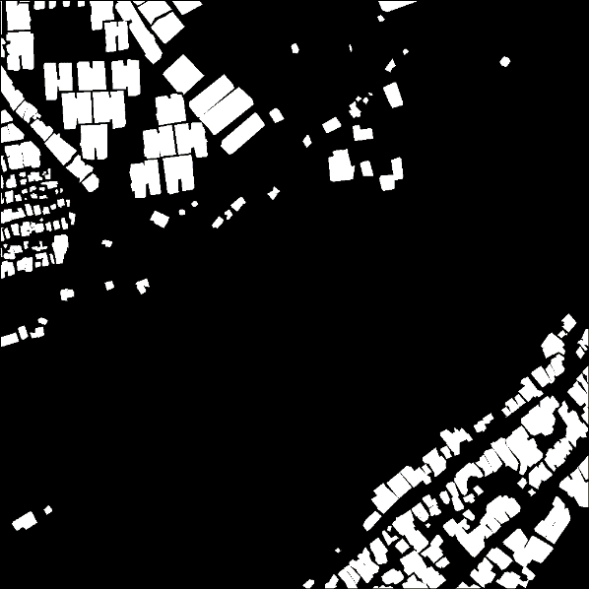

**Figure 26: Pre-Disaster Earthquake Original Image (Left) and Masked Image (Right)**

The data is split in the ratio of 80:20 (80% Training, 20% Testing). For U-Net model, the inputs are original images and the labels are masked images. The Chainer deep learning framework provides automatic APIs based on define-by-run and object-oriented high-level APIs which is used to build and train neural networks.

**Table 17: Train-Test-Split for Localization**

|  |  |  |
| --- | --- | --- |
| **Split** | **Images** | **Polygons** |
| Train | 4528 | 267983 |
| Test | 1133 | 48305 |

U-Net is a convolutional neural network framework that finds the features from inputs and provides classification. It has no dense layers and the model is connected layer by layer. The image is segmented based on class by producing a mask that will separate the image into several classes. The purpose of using U-Net is to localize and distinguish borders by doing classification on every pixel, so the input and output share the same size. The architecture of U-Net is shown in Figure 27.



**Figure 27: General U-Net Architecture**

After splitting of dataset, U-Net model is run with the hyperparameters as given in Table 18.

**Table 18: Hyperparameters Used in Training**

|  |  |  |
| --- | --- | --- |
| **Hyperparameter** | **Description** | **Value** |
| Batchsize | Number of images in every mini batch | 16 |
| Test_Batchsize | Number of images in every test mini batch | 4 |
| Epoch | Number of iterations over the training dataset | 100 |
| Activation Function | Give the resulting values between zero and infinity | ReLu |
| Loss Function | It defines how well an algorithm models the data | Cross-entropy |
| Optimizer | Updates the weight parameter to minimize the loss function | Adam |

To increase the stability of a neural network, batch normalization normalizes the output of a previous activation layer by subtracting the batch mean and dividing by the batch standard deviation.

**5.1.2 Model Training for Building Damage Classification**

To solve the classification problem, polygons are extracted from data. The original disaster images are given as an input and polygons are extracted from post disaster images. Python’s Open Computer Vision (OpenCV) library is used which is designed to solve computer vision problems. Shapely is used for polygon extraction. Figure 28 and 29 shows the execution of polygon extraction.

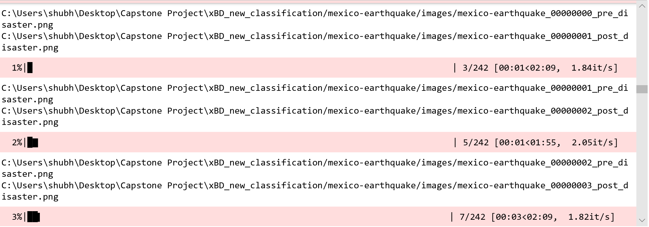

**Figure 28: Polygon Extraction in process**

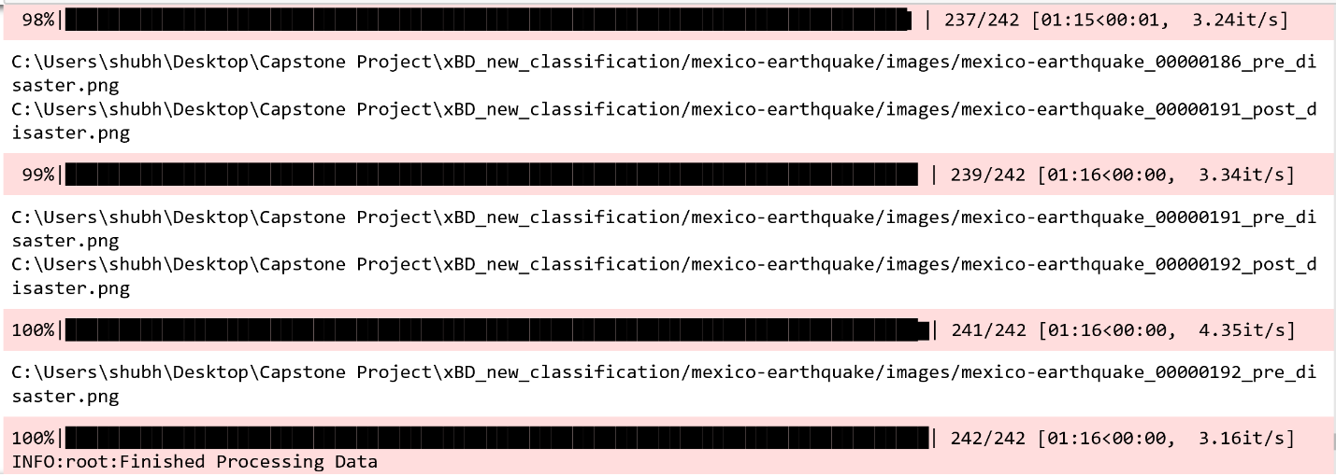

**Figure 29: Polygon Extraction in process**

The train - test split in 80:20 ratio, simultaneously while the polygons are being extracted.

**Table 19: Train-Test split ratio for classification**

|  |  |
| --- | --- |
| **Split** | **Images/Polygons** |
| Train | 252891 |
| Test | 63223 |

This results in generation of train.csv and test.csv which has damage type labels, polygon UUID and actual polygons from the original satellite images given as input. Figure 30 and Figure 31 shows data split in train and test.

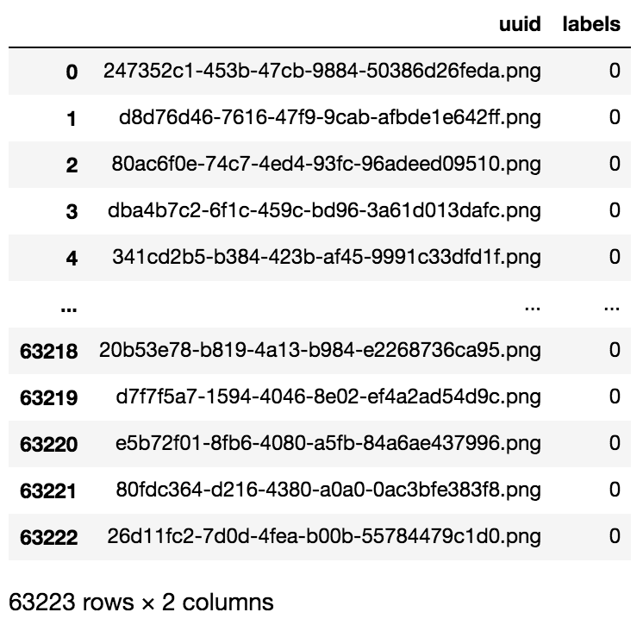

**Figure 30: Test.csv showing uuid and labels (damage)**

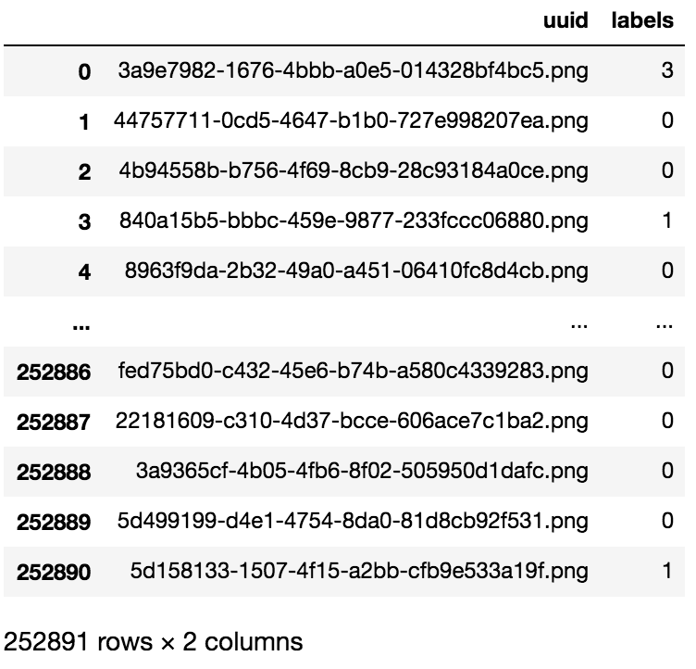

**Figure 31: Train.csv showing uuid and labels (damage)**

The output generate after polygon extraction is shown in blue color (Figure 32).

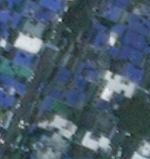

**Figure 32: Polygon Extracted from image**

ResNet model is used in training the dataset for damage classification. Residual networks are artificial neural network that works based on skip connections to jump over few layers. By skipping over the layers, the problem of vanishing gradients can be avoided. This is done by reusing the activations from the preceding layer till the adjacent layer learns its weights. (Figure 33)

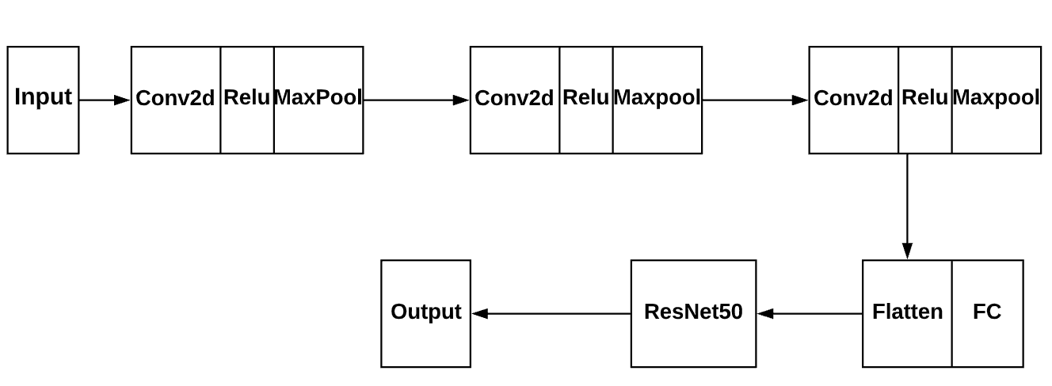

**Figure 33: Architecture of ResNet**

**Table 20: Hyperparameters Used in Resnet**

|  |  |  |
| --- | --- | --- |
| **Hyperparameter** | **Description** | **Value** |
| batchsize | Number of images in every mini batch | 64 |
| Learning rate | It determines step size at each iteration | 0.001 |
| epoch | Number of iterations over the training dataset | 100 |
| Activation function | Give the resulting values between zero and infinity | ReLu |
| Loss Function | It defines how well an algorithm models the data | Cross-entropy |
| Optimizer | Methods used to change neural network attributes | Adam |
| Data Augmentation | Creating modified version of the images in the dataset | True |

## 5.2 Model Execution and Evaluation

**Model Execution for Building Localization**

It took 17 hours to train U-Net model while running 100 epochs on HPC Server of SJSU.

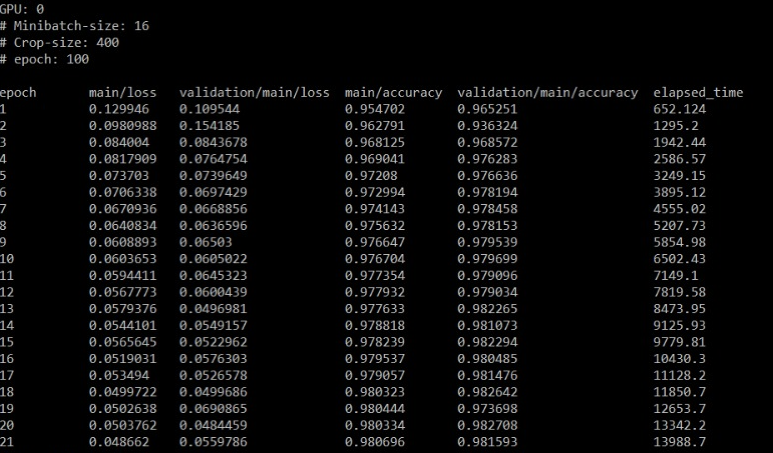

**Figure 34: Epochs Report**

The loss and accuracy graphs are shown in Figure 35 and Figure 36 respectively.

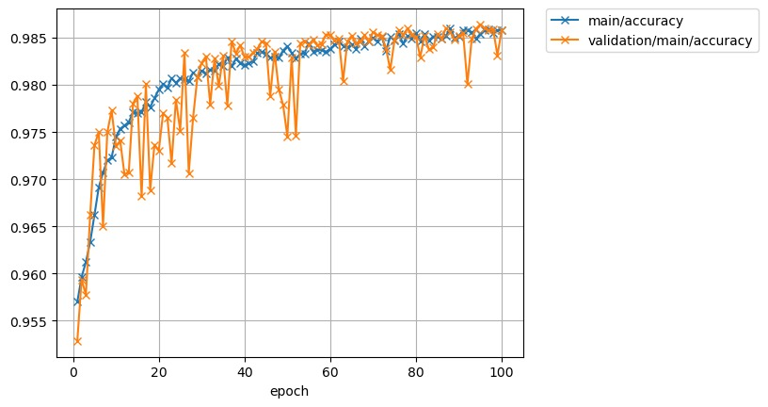

**Figure 35: Accuracy Graph**

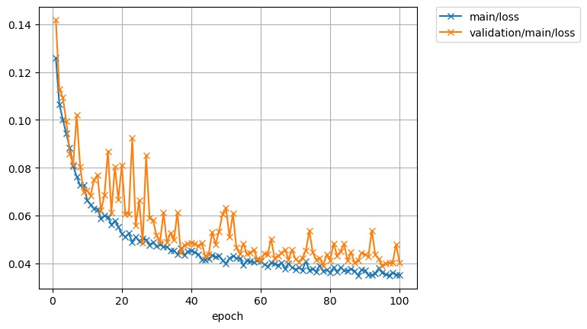

**Figure 36: Loss Graph**

The segmentation with ground truth image mask localization building is shown in Figure 37. Pre disaster image is given as input, segmentation and Input + Predicted buildings image is similar to Input + Ground truth buildings. The ground truth does reality check for presence of buildings, giving confirmation at the site for information obtained through remote sensing. [40]

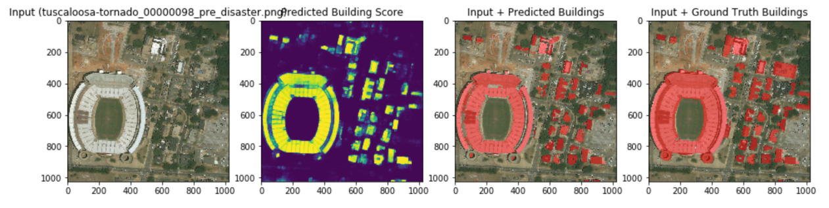

**Figure 37: Segmentation with ground truth**

**Model Execution for Building Damage Classification**

It took 27 hours to train 100 epochs of the ResNet model. The model execution gives validated image filenames belonging to 4 classes (0, 1, 2 and 3) for assessing building damage classification.

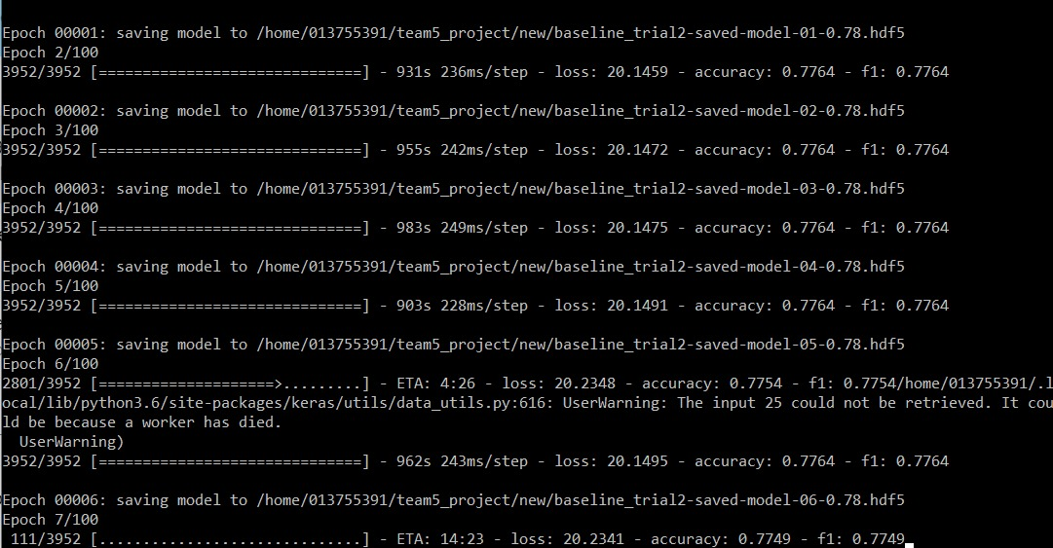

**Figure 38: ResNet Model Epoch**

## 5.3 Model Validation

Model Validation verifies that the model is performing as expected and in line with the objectives of the problem. While training model, val.txt is created which has 20% of data used for validation. Woolsey fire pre and post disaster image is given as input to U-Net model for running localization to detect presence and absence of buildings.

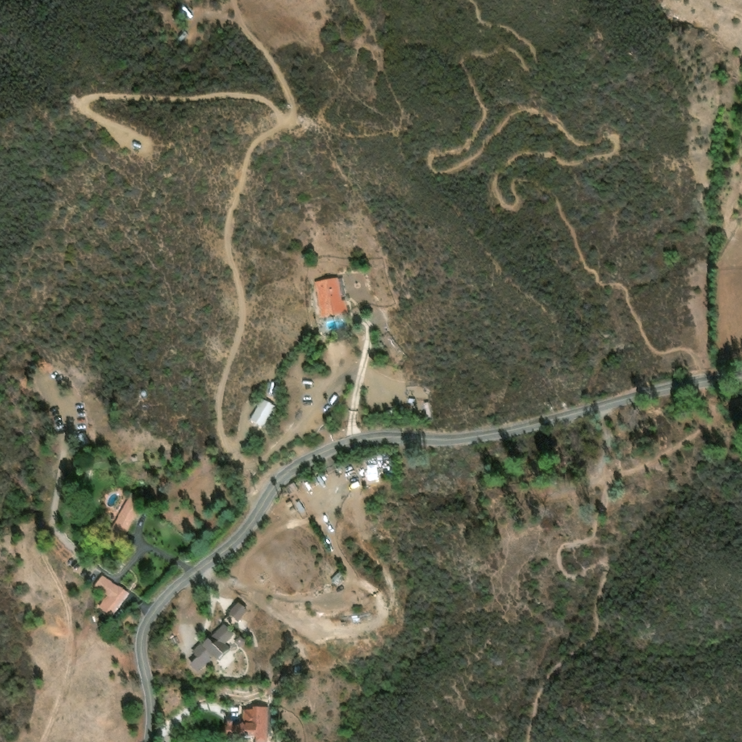

**Figure 39: Pre-Disaster Image of Woolsey fire**

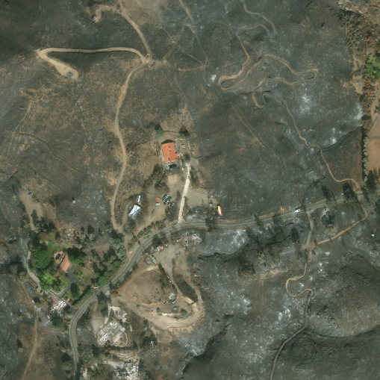

**Figure 40: Post-Disaster Image of Woolsey Fire**

Before training of model, the mask of pre disaster image is generated which is shown in Figure 41.

The masked image along with original image of pre disaster is passed as input parameter for training localization model, with masked image as label and image as original image. After the buildings are detected, post disaster image polygons are used as input for the classification model, which classifies the damage as no-damage, minor damage, major damage or destroyed.

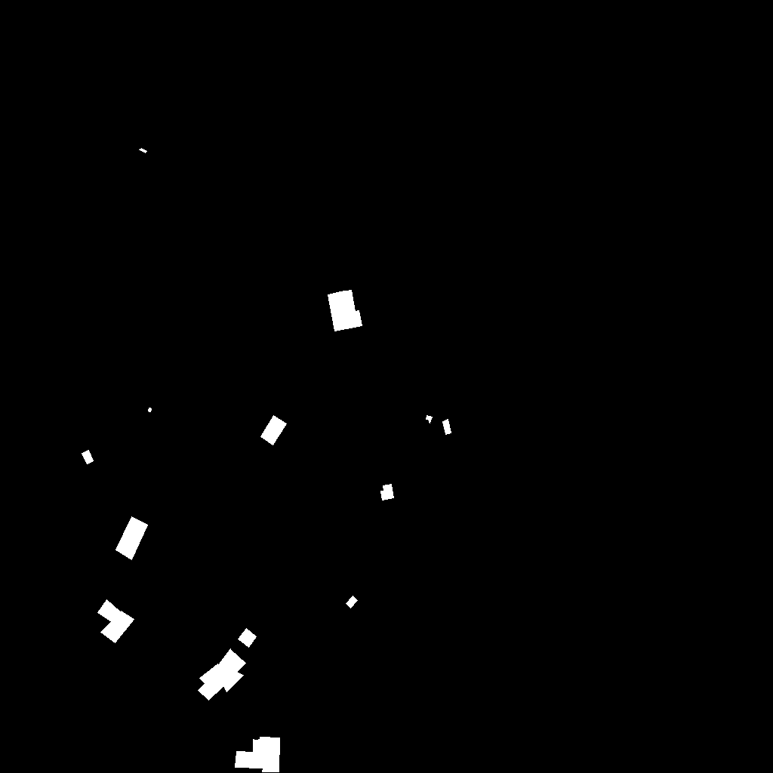

**Figure 41: Masked Image of Woolsey fire (Pre disaster)**

From pre disaster images as shown in Figure 39, we have obtained the white color objects which indicate the location of the buildings in the masked image. The combined results of the models generate a grey scale image in PNG format with its JSON file as shown in Figure 42.



**Figure 42: Output Image of Woolsey fire**

The above output image (Figure 42) shows grey scale object classification. Objects are classified as: White - Destroyed, Light Grey - Major Damaged, Dark Grey - Minor Damaged, Black - No Damage or Unclassified. This also can be validated with the JSON output file.

After the damage is classified as no damage, minor damage, major damage or destroyed, we have used a metric to convert the labels into a number to calculate the disaster index to better understand the situation.

$$Disaster Index=\frac{c1\left(N\left(L=2\right)\right)+c2\left(N\left(L=3\right)\right)+c3\left(N\left(L=4\right)\right)}{\sum_{i=1}^{i=4}{N\left(L=i\right)}}$$

Where:

c1,c2 and c3 are coefficients, where 1 >= c3 > c2 > c1

L=i: Intensity of the disaster

N(L=i): Number of buildings with disaster label i

In this case, the total number of buildings are 12. The number of buildings classified as minor damaged, major damaged and destroyed are 2, 1 and 9 respectively; and assuming the values of c1, c2 and c3 as 0.2, 0.3 and 0.5 respectively, our metric would result in $Disaster Index=\frac{0.2*2+0.3*1+0.5*9}{12}$ = 0.433, showing a 43.3% damage in the Woolsey area due to the fire, based on our damage classification labels and the input images provided to the model.

# 6. EVALUATION AND VISUALIZATION

## 6.1 Analysis of Model Execution/Evaluation Results

To evaluate our model, we used different evaluation metrics to know how well the model performed. Some of the metrics we used to evaluate our model are given below:

**For Segmentation and Localization:**

**Pixel Accuracy**: It gives the percentage of pixels in an image that is classified correctly. High pixel accuracy doesn’t always imply superior segmentation.

**IoU**: Intersection over union is an evaluation metric used to measure the accuracy of an object detector on a dataset. For IoU the requirements are ground-truth bounding boxes and predicted bounding boxes from our model. [41]

**Class Accuracy**: It is the rate of correct classification of classes [42]. Table 21 shows the values for defined metrics.

**Table 21: Evaluation metrics for localization and segmentation**

|  |  |  |
| --- | --- | --- |
| **Metric** | **Class Label** | **Value** |
| IoU | 0 (No Building) | 0.98800848 |
| 1 (Building) | 0.63511949 |
| Pixel Accuracy | NA | 98.8% |
| Class Accuracy | 0 (No Building) | 0.99695511 |
| 1 (Building) | 0.69933148 |

The mean class accuracy is 0.84814.

**Precision**: This shows ‘how much the model is right when it says it is right’. It is a percentage of positive instances out of the total predicted positive instances.

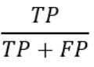

The precision value of our model is 0.87369070.

**Recall**: These show the positive instances out of the total actual positive instances. Therefore denominator (TP + FN) here is the actual number of positive instances present in the dataset.

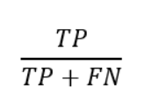

The recall value of our model is 0.6993314.

**F1 Score**: This represents the harmonic mean of precision and recall. Higher the value of F1 score, better it is as it considers the contribution of both the precision and recall.

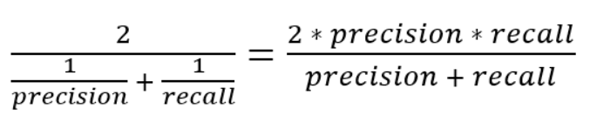

The F1 score value of our model is 0.776.

**Confusion Matrix**: It is an apt representation of a summary of the above metric. It is a visual form which can be easy to interpret. It is used to find the correctness and accuracy of the model. It is best for classification problem where output contains two or more type of classes.

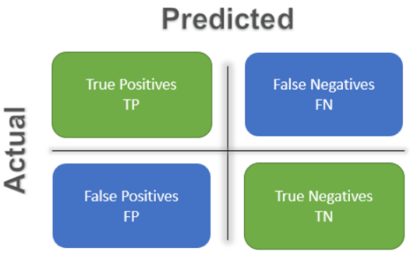

The confusion matrix for our localization model is shown in Figure 43**.**

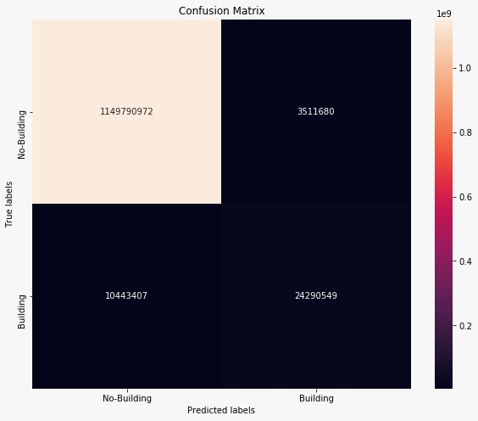

**Figure 43: Localization model confusion matrix**

**For Damage Classification:**

We have used a weighted F1 score as a metric for evaluating the performance of our model. There are many measures to evaluate the performance of the model, one of which is accuracy. However, calculating accuracy would not have been an optimal metric because of the imbalance in our data.

The imbalance in our raw data is shown in Figure 44.

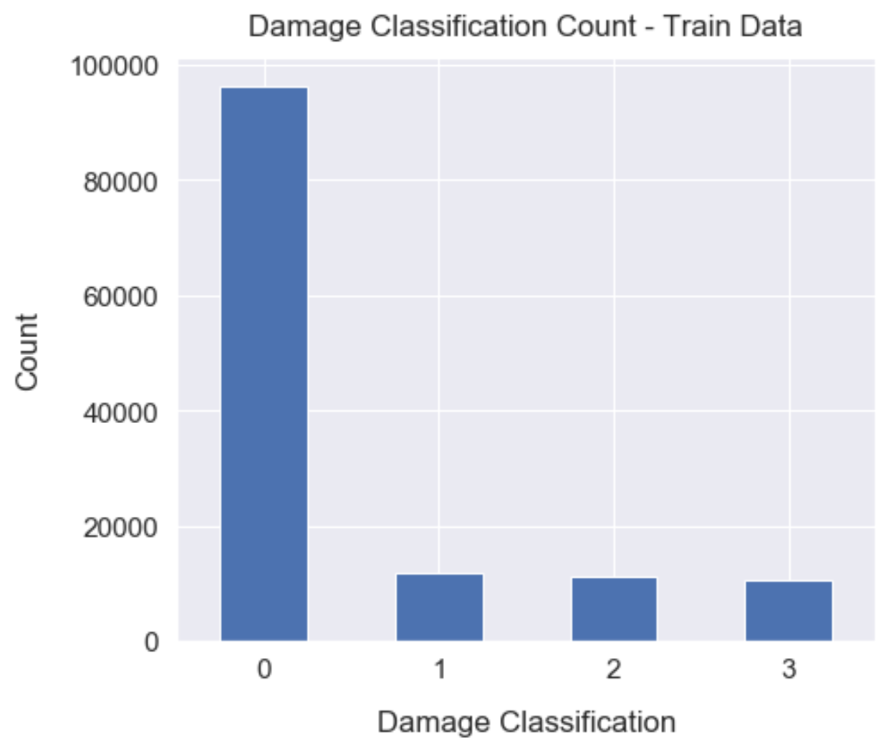

0: No Damage

1: Minor Damage

2: Major Damage

3: Destroyed

**Figure 44: Damage Classification Imbalance**

Since, most of the images belong to label 0: No damage, accuracy would have been a flawed metric, as any classifier would have predicted most of the images as “no damage” with a high accuracy. Therefore, by using a weighted F1, we are balancing the precision and recall by taking harmonic mean of both. We have obtained a F1 score of 0.63.

**Recall**: These show the positive instances out of the total actual positive instances. Therefore denominator (TP + FN) here is the actual number of positive instances present in the dataset.



**Classification Report**: It is used to measure the quality of predictions from a classification algorithm [43]. The classification report showing all the metrics is as below:

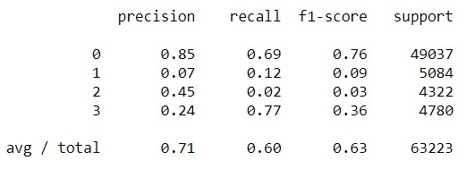

**Figure 45: Classification Report**

**Confusion Matrix**: It is an apt representation of a summary of the above metric. It is a visual form which can be easy to interpret. It is used to find the correctness and accuracy of the model. It is best for classification problem where output contains two or more type of classes.

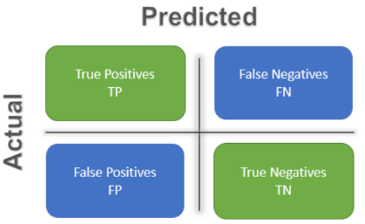

The confusion matrix for our classification model is shown in Figure 46**:**

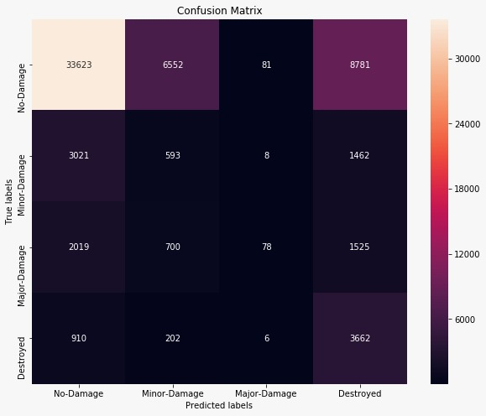

**Figure 46: Classification Confusion Matrix**

## 6.2 Achievements and Constraints

The building recognition using remote detection technique has consistently been a difficult task, as buildings design differs depending on where it is located around the world. Buildings are of different structures, scales and shades which make building detection complex. Sometimes, the objects cannot be identified if the images are of low resolution. The advancement of deep learning technique improved the building detection task, by using the availability of satellite images.

For solving this complex problem of classifying the building damage, use of deep learning models helped in achieving the desired results. For training a huge dataset of around 30 GB size, we used U-Net architecture model and ResNet model which outperformed traditional machine learning algorithms. Our model can perform tasks of damage assessment which can help in resource planning, reconstruction and logistics. It can be done within a shorter timeframe as compared to what it would take for an individual to do manually. Residual networks allow training of deep networks by developing the network through modules called residual models. Extracting and analyzing pre and post disaster situation when integrated with information and communications technology systems help in estimating damage costs and identification of impacted buildings with minor or major damage, which can be restructured and buildings with no damage can be used for shelter in place for people. Testing of images become challenging due to various reasons like image quality and distance from which it is captured but deep learning model represented those varieties and learnt significant highlights to make the examinations better with transfer learning and feature engineering.

Deep Learning model required high end infrastructure for intensive training. Working on CPU required 1 hour for 1 epoch to train on a smaller subset, however availability of GPU took 10 minutes for 1 epoch on the whole dataset for localization of buildings. The downside to U-Net style structures is that learning may back off in the center layers of deeper models. Therefore, there is some risk of the system not figuring out how to disregard the layers where dynamic highlights are shown. Since deep learning model is a black-box, it is not clear to comprehend inside each layer which made interpretability an issue.

## 6.3 Quality Evaluation of Model Functions and Performance

As deep learning models are additionally incorporated into day by day tasks to solve complex problem, the time a deep learning algorithm takes to run on infrastructure isn't probably going to be the equivalent at each run. The factors on which it depends are:

* **Size of Data** - The dataset size was huge which took time in computing.
* **Complexity of Algorithm** - UNet and ResNet models have complex network.
* **Infrastructure Availability** - Availability of nodes per CPU/GPU, RAM, Input/Output speed

Considering above factors, localization and classification model were run using High Performance Computing (HPC) of San Jose State University [39]. This system has total of 36 nodes with 20 nodes (compute nodes) having 128 GB RAM and 16 nodes (GPU and condo nodes) having 256 GB. It provides 100 TFlop/s of peak performance.

Runtime is the period of the program lifecycle that executes and keeps a program running. Elapsed time is the measure of time that goes from the beginning of an event to its completion including delays and wait for resources. It is one of the criteria that requires least runtime.

For localization (U-Net), It took 1 hour to run 1 epoch on CPU whereas on GPU it took 10 minutes for 1 epoch. For damage classification (ResNet), it took 2 hours to run 1 epoch on CPU whereas on GPU it took 20 minutes for 1 epoch to run. Overall, the localization model took approximately 17 hours to run 100 epochs, whereas the classification model took about 27 hours to run 100 epochs on GPU. This clearly shows the run time difference among models on different resources.

The elapsed time on GPU for U-Net is shown in Figure 47 and for ResNet on GPU in Figure 48.

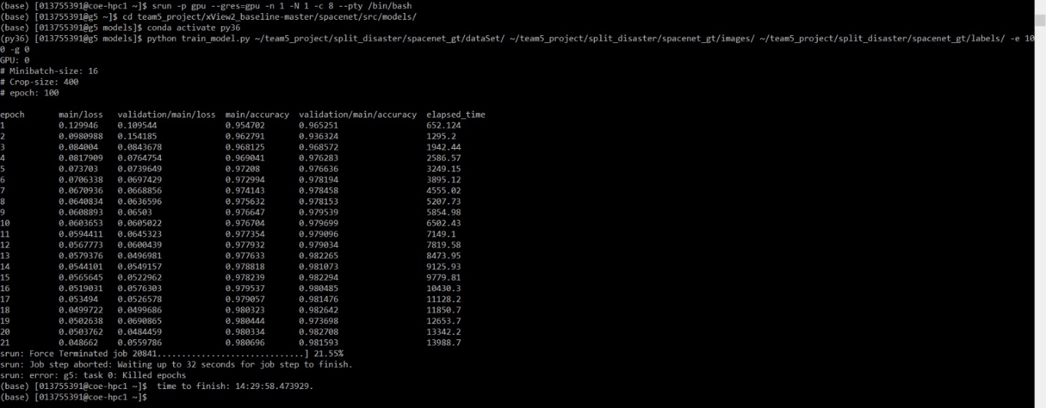

**Figure 47: Elapsed time per epoch on GPU (U-Net Model)**



**Figure 48: Elapsed time for epochs on GPU (ResNet Model)**

## 6.4 Evaluation of Models vs. Requirements

Gathering requirements and assessment are significant activities for the accomplishment of the project, both for ensuring forward advancement in the improvement of the project framework and procedure, and for guaranteeing that the created models are fit for reason. A general structure for completing convenience and execution assessment of the model will focus on the technical, functional and non-functional requirements. The Table 22 shows the individual parameters on evaluating the model v/s the requirements.

**Table 22: Individual Model Elements**

|  |  |  |
| --- | --- | --- |
| **Element** | **Requirement Specified** | **Description** |
| Scientific basis | Technical | The models U-Net and ResNet have been popular algorithms for object identification and classification respectively. These models were chosen based on research of previous experimental results and applications of model. |
| Computational Infrastructure | Technical | The model required GPU for storage and computation of data. It is time consuming when model was trained using CPU |
| Data availability and quality | Technical and Functional | The accessibility and nature of data that can be utilized for both creating model info/input parameters and evaluating model outcomes is fine. |
| Benchmarking against different models | Technical and Functional | U-Net and ResNet models used have their application for localization and classification respectively when compared to other classification models like Random Forest, CNN |
| Transparency | Non-Functional | The accessibility and nature of data that can be understood for creating model info/output parameters and its output results is transparent. |
| Documentation Requirements | Non-Functional | Documentation requirements refer to those prerequisites that are identified with the usage of project. The project states the input parameters to be passed along with benefits and output results. |

## 6.5 Information Visualization

According to our dataset, Figure 49 shows the disasters occurred in each country. It highlights the major disaster based on the maximum number of records. For example, in USA, flood, fire and volcanic eruption have occurred, but flood has been the most frequently occurred disaster.

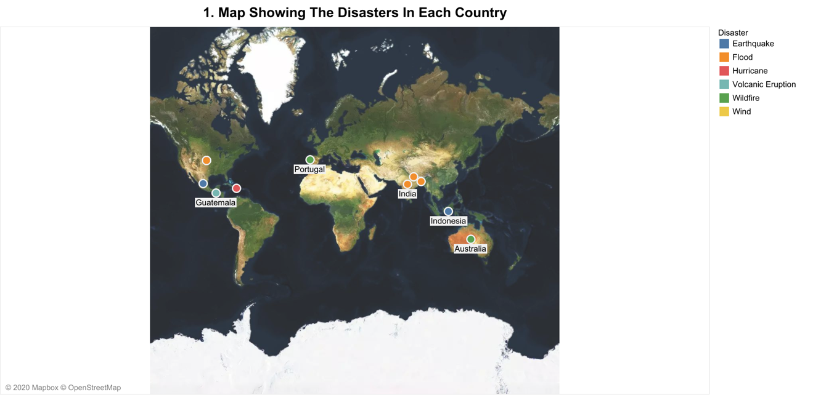

**Figure 49: Map showing the disasters occurred in different country**

According to our dataset, Figure 50 shows the disasters occurred in USA.

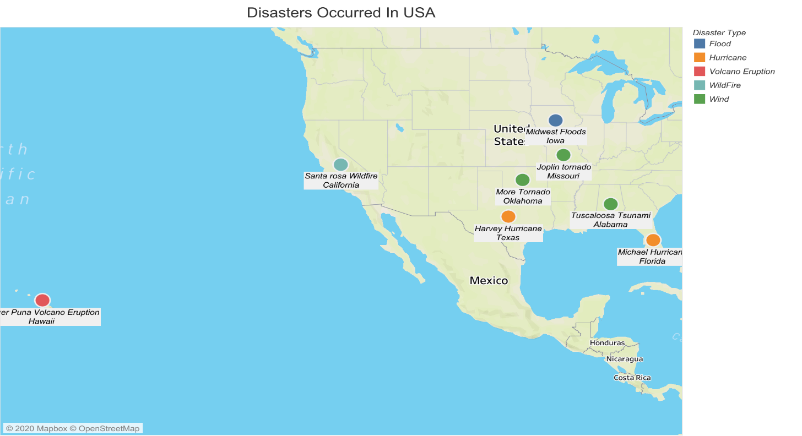

**Figure 50: Map showing disasters occurred in USA**

Figure 51 shows the number of records (images) captured by each sensor. The graph shows the disasters captured by each sensor and it is grouped based on the sensor name. It shows that most of the images are captured by the WORLDVIEW02 sensor providing better quality images.

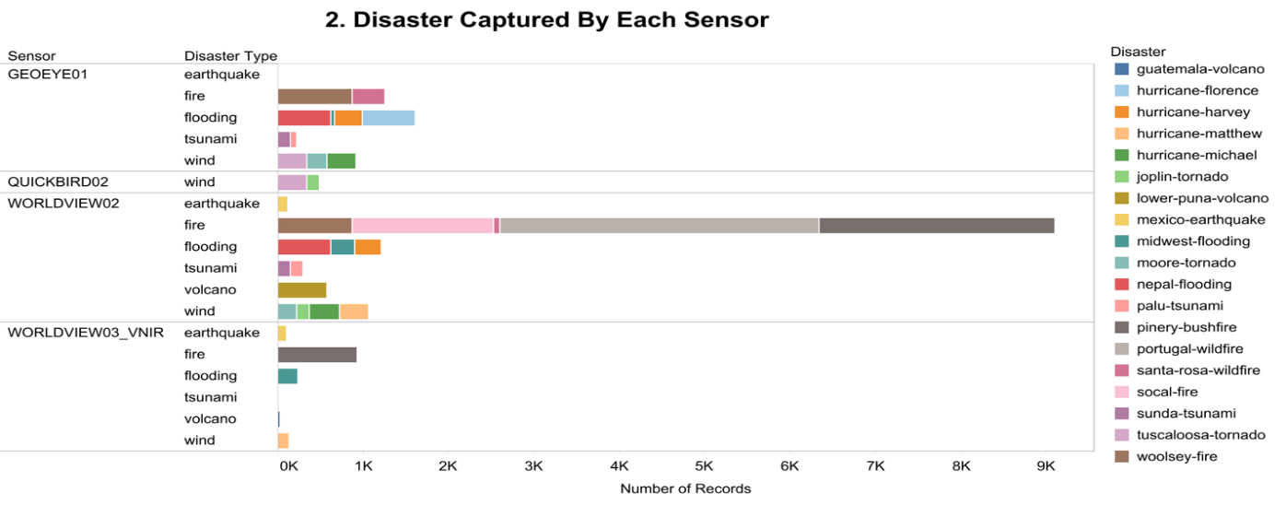

**Figure 51: Disaster Captured by Each Satellite**

Figure 52 shows the count of destroyed structures during each disaster. The result is grouped based on disaster type. From the graph its seen that most damage is caused due to the disasters occurred by fire. The structures are less destroyed by earthquakes.

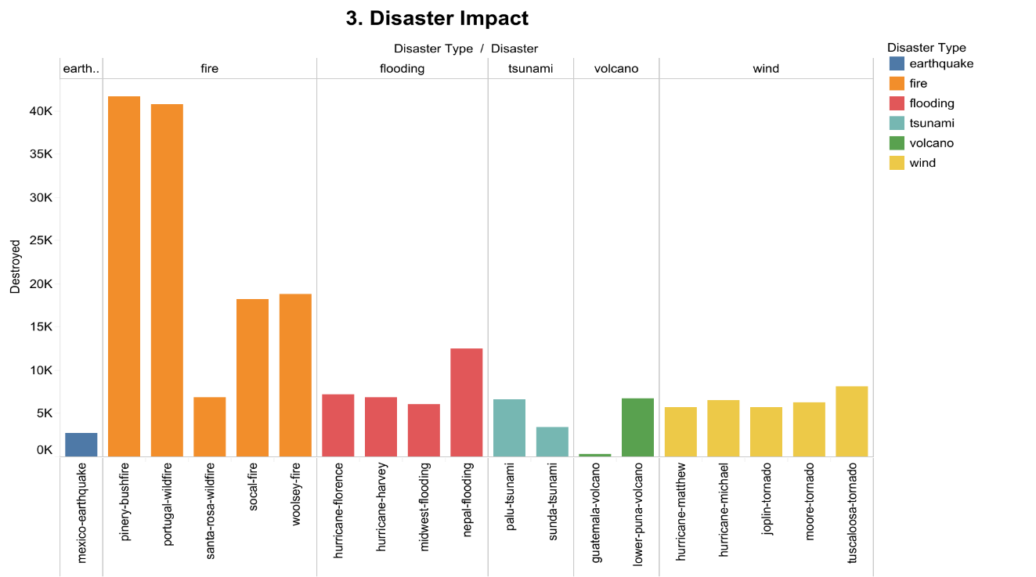

**Figure 52: Disaster Impact**

Figure 53 is created considering the different levels of damage occurred due to each disaster. It shows the count of minor, major, and no damage labels in each disaster. From the pie chart we can say that most damages are occurred due to disasters caused by fire.

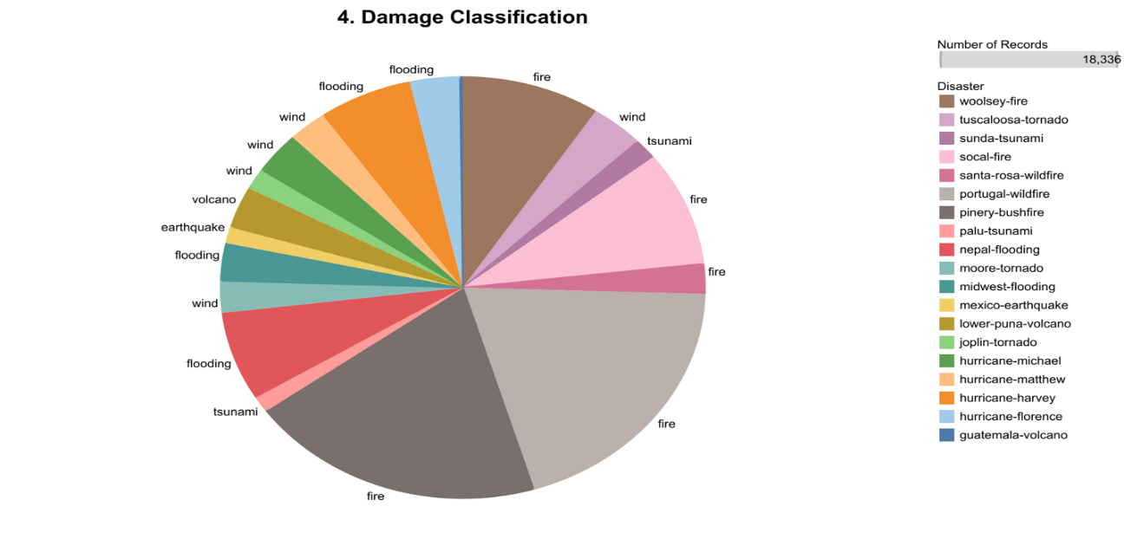

**Figure 53: Damage Classification**

An interactive dashboard using Power BI is created displayed in Figure 54.

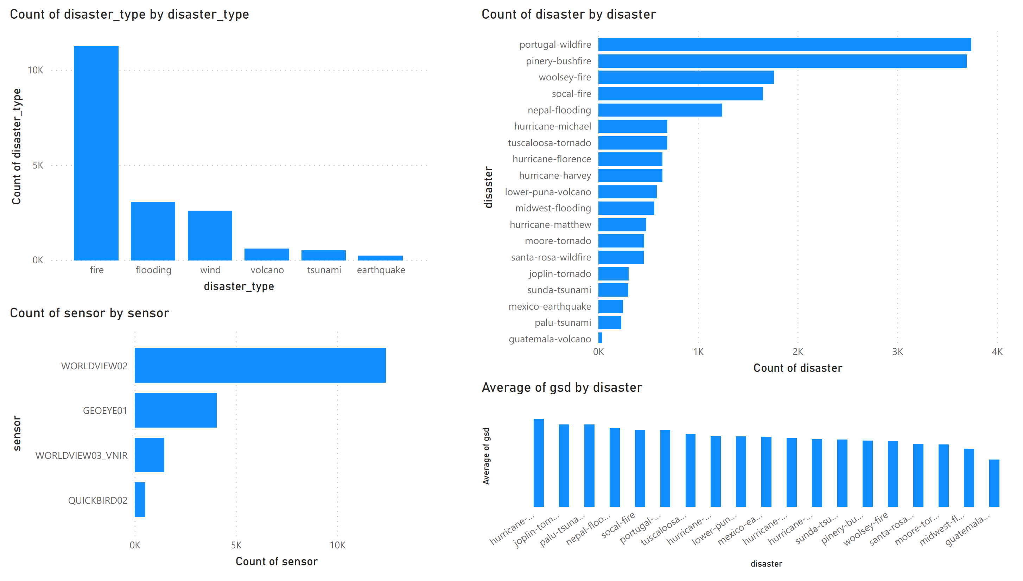

**Figure 54: Interactive Power BI Dashboard**

Figure 55 shows Santa Rosa wildfire - California, pre and post disaster images with annotations. In pre disaster annotated image, green color polygons depict the buildings. In post disaster annotated image, different color depicts level of damage classification (green: no-damage, blue: minor damage, orange: major damage, red: destroyed, black: un-classified).

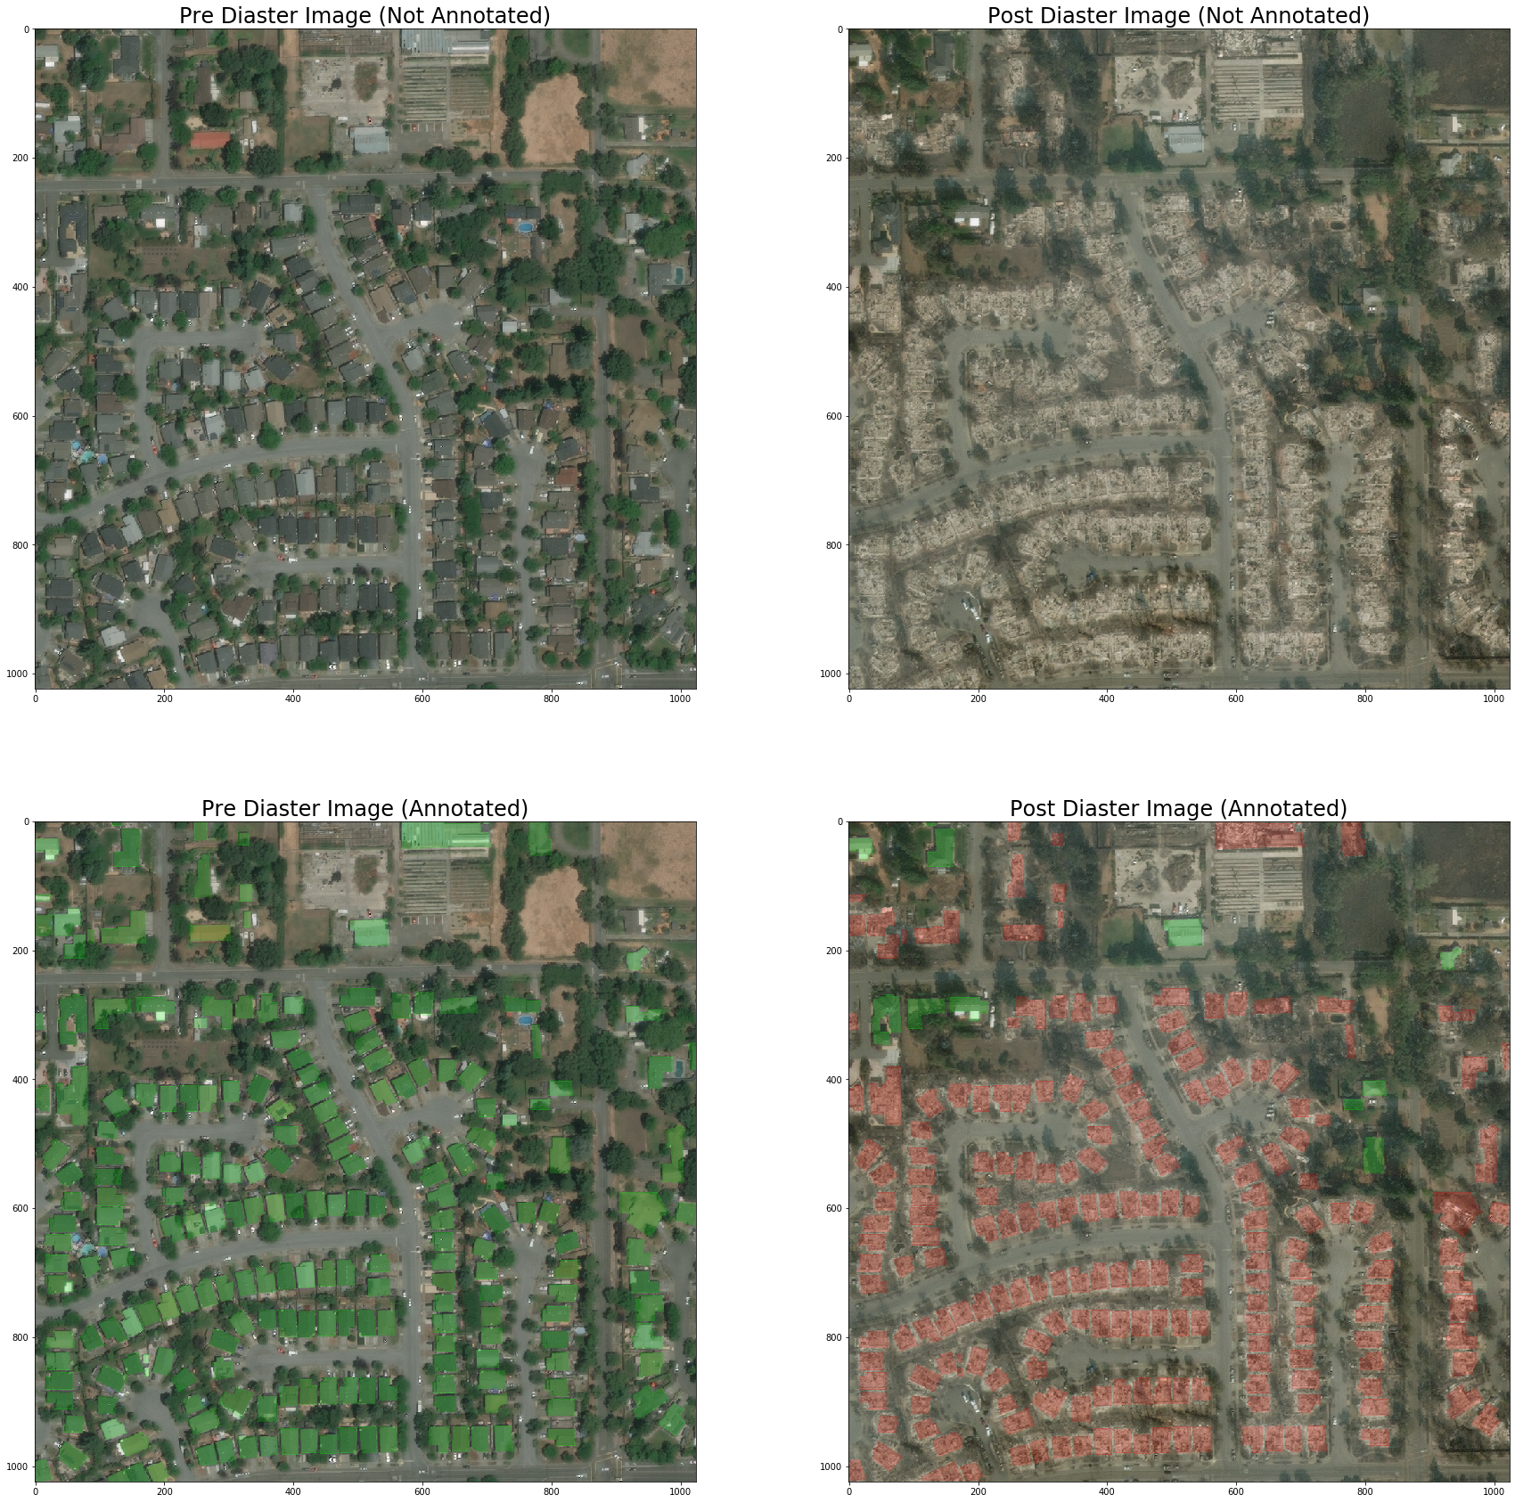

**Figure 55: Santa Rosa Wildfire, California – Pre/Post Disaster Images with Annotations**

Figure 56 shows the Santa Rosa wildfire map location in which different circle depicts levels of damage classification (green: no-damage, blue: minor damage, yellow: major damage, red: destroyed, black: un-classified). Each polygon is mapped using the latitude and longitude coordinates. We are using this to highlight the most affected locations by the disaster. The circles represent the polygons of the label types. More the number of polygons of the label type (no damage, destroyed, etc) in the image, the greater is the size of the circle.

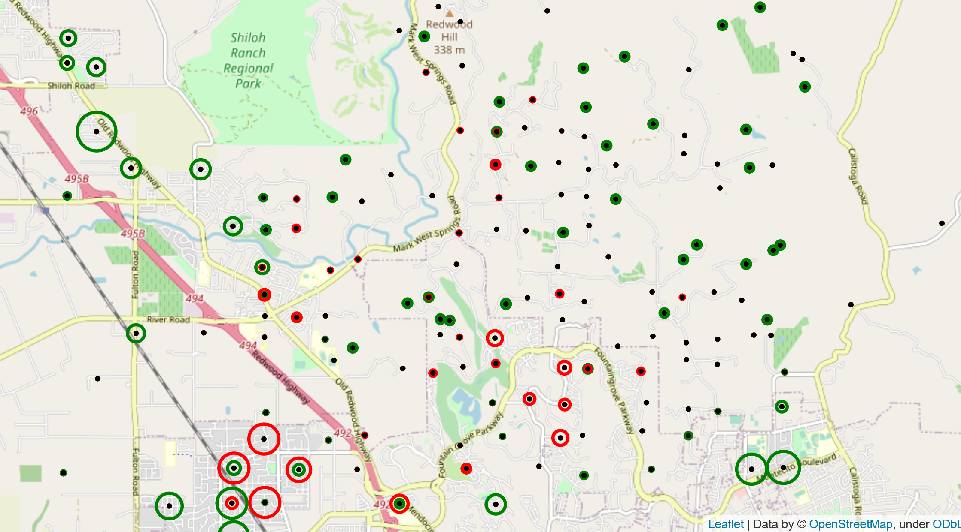

**Figure 56: Santa Rosa Wildfire, California - Damage Building Location Map**

**6.5.1 Model Deployment**

**Flask:** It is easy to use web application framework written in python. Packages for using flask were installed as conda install flask. flask-app was set over the localhost and default port (5000) and making the URL as http://127.0.0.1:5000/ shown in Figure 57.



**Figure 57: URL for frontend interface**

The diagrammatic representation of the data flowing between the user and server space is shown in Figure 58. Front end designed using flask in python accepts images in the form of user input and generate output in the form of image. The model data flow is shown in Figure 59.

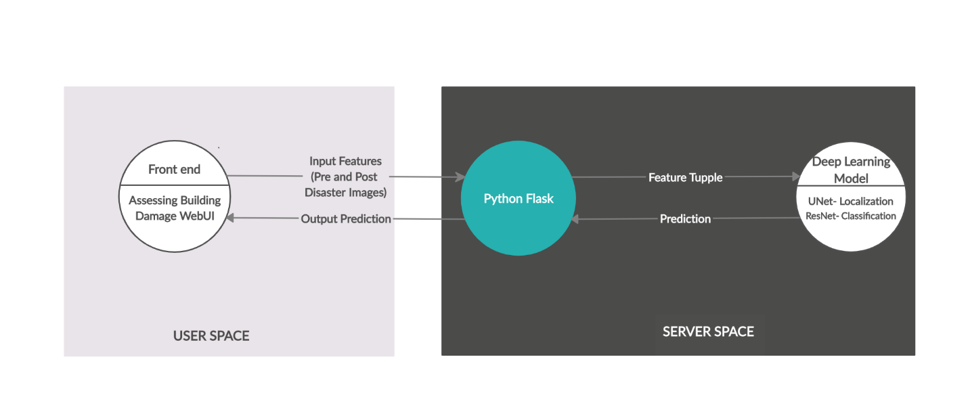

**Figure 58: Data flow between user and server space**

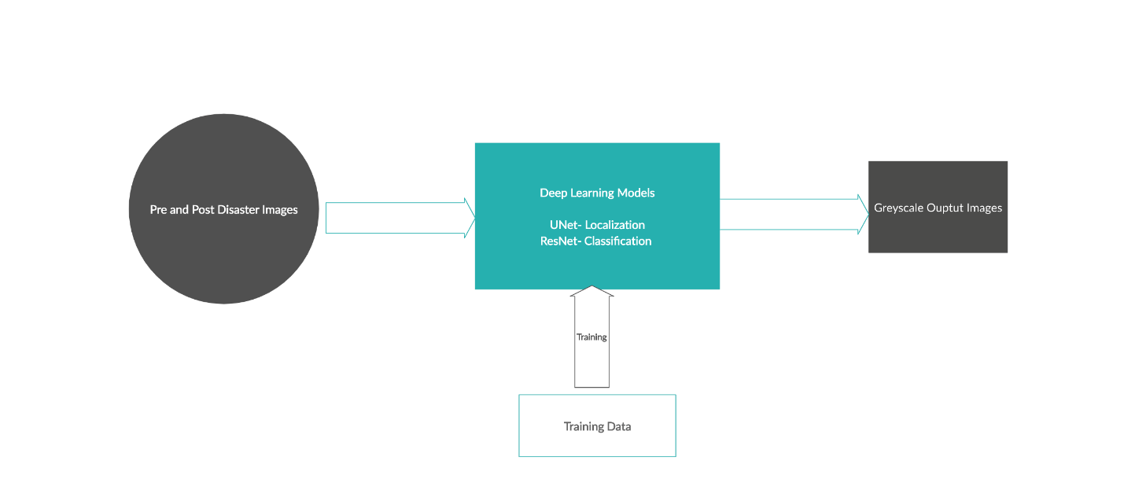

**Figure 59: Model data flow**

The interface uses HTML and CSS for styling background. It is shown in Figure 60 - Figure 64.

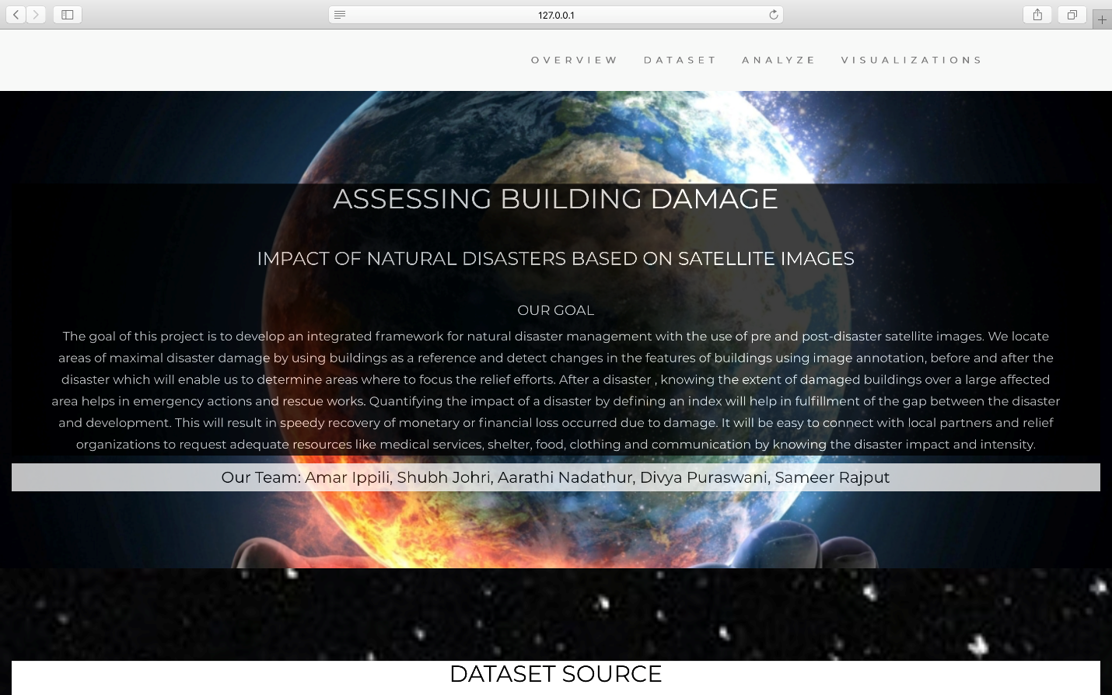

**Figure 60: Front end - Overview tab**

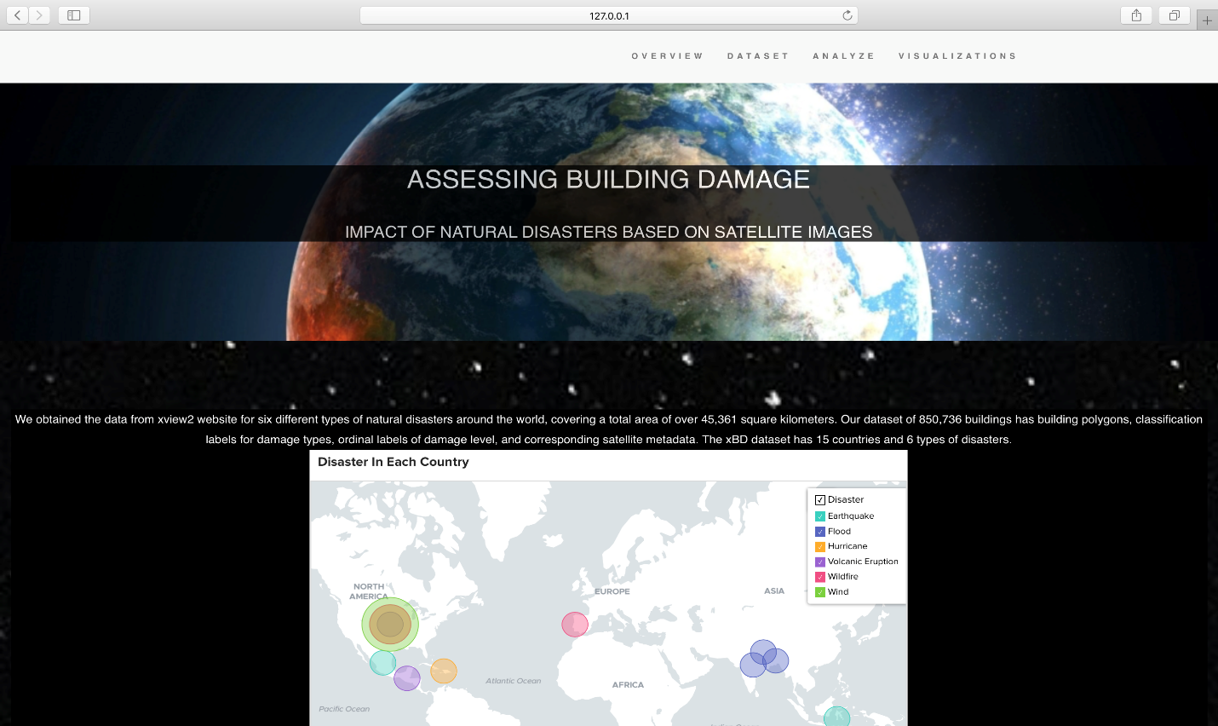

**Figure 61: Front end - Dataset Tab**

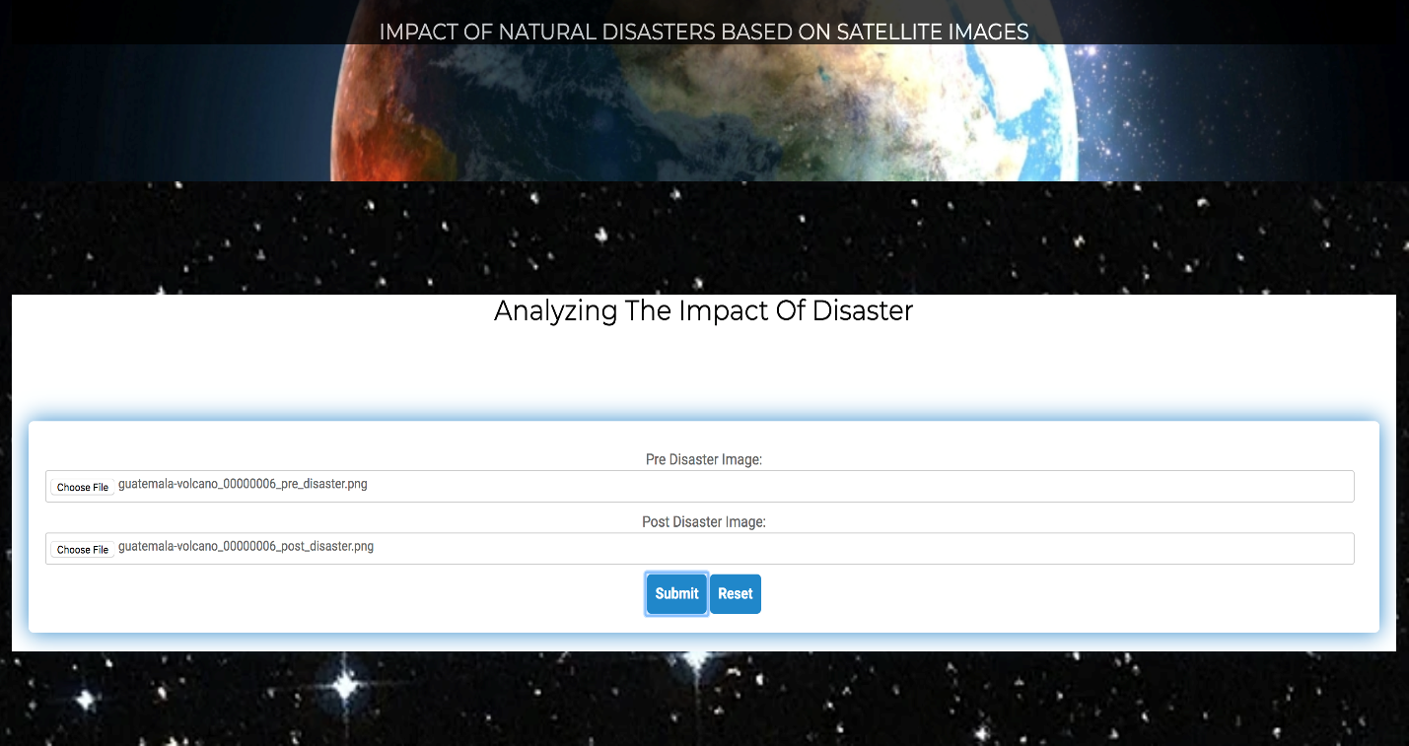

**Figure 62: Front end - Analysis Tab**

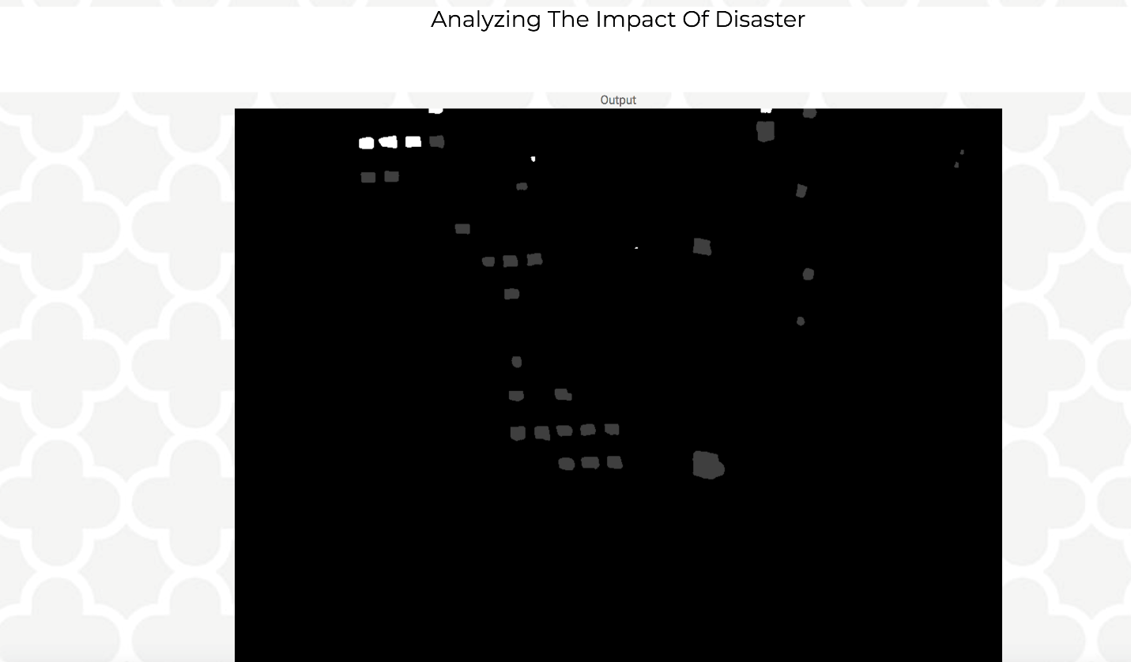

**Figure 63: Front end - Output Image**

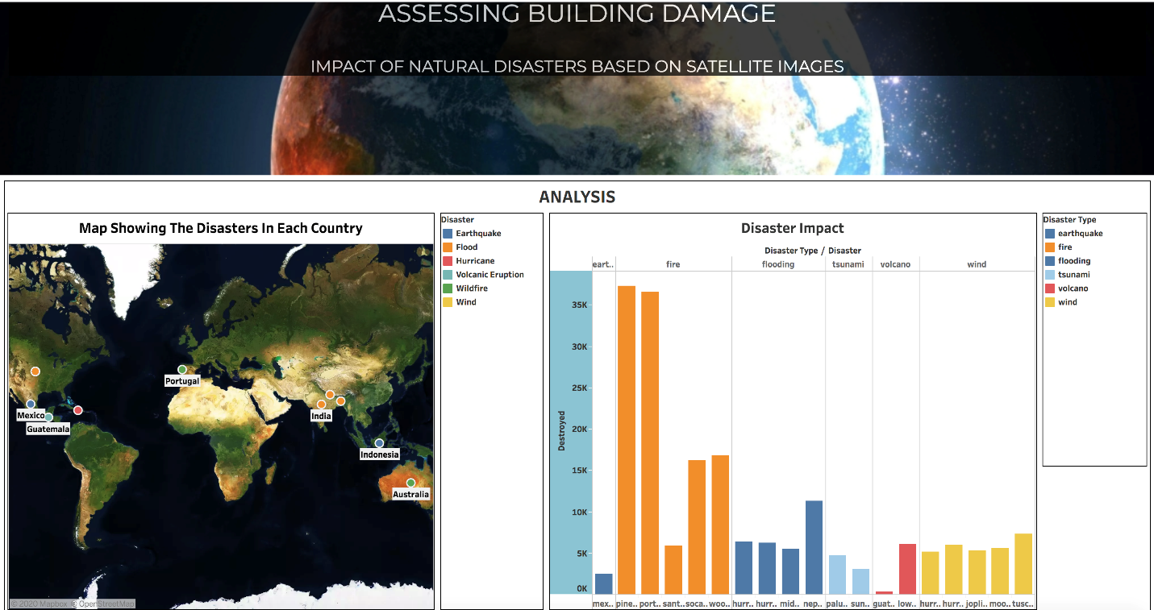

**Figure 64: Front end - Visualizations tab**

# 7. CONCLUSION

## 7.1 Summary

Natural disaster relief and response agencies require an accurate understanding of damaged buildings in an affected area. To deploy resources in affected regions, it is crucial for emergency responders to know the affected areas and severity of the damages. The increasing availability of satellite imagery gives a powerful source of insights and can be used to collect information about the extent and locations of the damage. The change detection and disaster damage assessment process require huge amount of manual work and labor by satellite imagery analyst. These procedures can take several hours in a situation where time is crucial in saving lives, but a timely change detection can save lives.

Recognizing an opportunity to solve a key analytical problem for the humanitarian assistance and disaster recovery organizations. We tried to develop a solution with the use of deep learning techniques that automatically detect the building structures on the ground and predict the scale of the damage to the building after the natural disaster has occurred. We took xBD satellite images dataset which includes pre-and post-disaster images for six different types of disaster and fifteen countries.

Our model can localize building and classify building damage using pre/post disaster images. We used a U-Net architecture model for localization of buildings and ResNet model for damage classification. The neural network models, ResNet and U-Net based on CNN architecture are used in parallel as components. Our model includes both a network pre-trained on ImageNet weights and an initially untrained network which trains on the features generated by the pre-trained model. These two models – U-Net and ResNet work as simultaneous feature extractors, and we combine their features by concatenating their outputs and feeding the result to a network of several dense layers. U-Net model detects presence of building as an object in an image and ResNet attempts to classify damages with labels ranging from 0 to 3. We followed the model pipeline as depicted below in Figure 65.

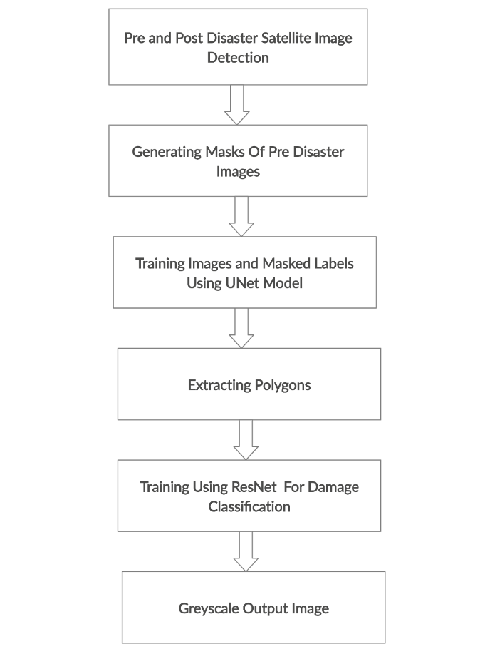

**Figure 65: Model Pipeline**

Masking technique is used which allows buildings (objects) to highlight within an image by removing or blurring the background. It is done on pre-disaster images to detect the buildings. To solve the classification problem, the post disaster images are given as input and polygons are extracted from the images. Shapely python package is used for polygon extraction.

## 7.2 Benefits and Shortcoming

Deep learning techniques have achieved human level performance on several computer vision tasks, which includes image segmentation and object detection. We have used these techniques for disaster localization and disaster damage classification, as they are highly relevant and applicable in the satellite image analysis. We used U-Net architecture for localization of buildings and ResNet model for damage classification.

By combining both the U-Net and ResNet model, we are essentially using computer vision to scan the satellite images of buildings before and after a disaster hits a region. By scanning both these images of pre and post disasters, the model can differentiate the pixels distortion in the images and hence, is able to find buildings and then classify their damage.

There exist multifold benefits with this solution to the damage classification problem. The authorities working on the ground level could initiate faster recovery methods following a man-made or natural disaster. A solution like ours could help the first responders with all the information to save the victims to these disasters and help keep the responders safe.

With benefits like these, our project problem possesses a couple of shortcomings. Our project problem is limited to just one feature of buildings due to the limited satellite data present today. We tried using the data we collected to solve the same damage classification problem for other features like roads, trees and large grounds. However, we could not extend our solution to the additional features due to the limited number of these features present in our dataset.

With these additional features, our solution would have used satellite imagery to detect the damage in the overall architecture of a region and would be able to communicate to the responders of these damages so that they would be aware of the roads that were still operational and air fields which could be used receive or provide aid.

## 7.3 Potential Model Applications

We used two deep learning models for our problem, U-Net model for localization of building and ResNet model for building damage classification. The U-Net model architecture is built on the Fully Convolutional Network and modified in a way that it gives better image segmentation results. Image segmentation is a process that allows us to separate object and textures in an image. U-Net is considered as one of the best networks for fast and precise segmentation of images. Not only it defines whole image by its class but also segment areas of an image by class. It produces a mask that will separate an image into different classes. Its architecture allows contracting path to capture context and a symmetric expanding path that enables precise localization. This model is especially preferred in applications such as remote sensing, biomedical image diagnosis, geo sensing and environmental engineering. The segmentation of map regions, by using the satellite imagery is another U-Net application. Its application greatly facilitates the work of mapping and environmental engineers. It will help in urban district planning applications and defense industry applications. This model helped us in our problem to detect the buildings from the satellite imagery and enabled precise localization.

ResNet is a subclass of convolutional neural network; it is mainly used for image classification. Many visual recognition tasks have been greatly benefited from deep neural networks. From many years there is a trend to go more deeper into neural network to solve more complex classification and recognition problems. But, as it goes deeper, the training of model becomes difficult and the accuracy starts saturating and then degrades. ResNet architecture tries to resolve these problems. It is especially preferred in computer vision applications like image classification, scene labelling, action recognition and face recognition. We used this model as it achieves better accuracy in image classification tasks compared to other convolutional neural network methods.

Some of the potential applications which could result from our solution could be –

* **Urban district planning** – Our model has the potential to provide ideas to architects to plan a region in a way which is ready with a response to sudden disasters.
* **Defense Industry** – The defense industry can utilize a model like this to understand disasters inflicted my humans during war and asses the scale of the damage.
* **Environmental engineering** – Engineers can use the model to understand the impact of the damage in buildings, roads and trees so that re-building these features are easier.
* **Obstructed Road Segmentation** – Our model could identify the roads that are obstructed during a disaster or are broken – covered with debris or floods.
* **Routing Across Obstructed Roads** – A solution model like ours can detect obstructed roads which would provide advanced routing capabilities to first responders and disaster planners who need to know how to navigate through a disaster environment in order to provide aid to the severely hit areas.

## 7.4 Lessons Learned

* Computer vision and satellite imagery combined can automate and accelerate damage assessments in the aftermath of a natural disaster. Satellite imagery can be used to communicate to the responders about the on-ground reality after a natural disaster hits, so they are better prepared to assess the damage.
* The satellite imagery could present some limitations. Sometimes it is not possible to get the damage assessment from post disaster satellite imagery, as buildings may either be created after the disaster or may be not visible due to other factors like haze or cloud obstruction.
* It is difficult and time-consuming process to train a high-resolution satellite images data on local server. The only possibility is to use high computing performance system or cloud platform with GPU, high performance storage and large amount of memory to process high resolution satellite images to train a deep learning model.
* One of the most crucial stage in data science workflow is exploratory data analysis (EDA). Data exploration is done to understand data strengths and gather insights, based on the learnings a model should be selected and fine tune it accordingly to so we can get the best accuracy results. In our case, EDA was done on the imagery data in the form of pixels to better understand the properties of our image data.

## 7.5 Recommendations for future work

* Investigate different techniques to make the deep learning model more stable to data flaws. For example, we can give random translations in training the images to make the model more stable to misalignment between pre and post disaster images.
* Extend the training dataset with different types and resolution of pre-post disaster images to train our model, so our model can perform more accurate and precise.
* Satellite image dataset can also be used for damage road segmentation. Models can detect damaged road that would provide advanced routing capabilities to rescue team and disaster planners who will get to know how to navigate through a disaster area.
* It would be practical to consider a pretrained model for processing a large image data and running a deep learning model. Pretrained model will require less samples to fine-tune and it will take less time to give results.
* Additional features like roads, large fields, airfields and trees could be included in the dataset so that the whole architectural damage impact could be calculated for a region.

## 7.6 Contributions and Impacts on Society

Our project contributes for the advancement of change detection and building damage assessment for disaster recovery research and humanitarian assistance. When a disaster strikes, an accurate understanding of the affected region and damage intensity information is critical to an effective response. Resource planning, damage estimation and logistics are major difficult tasks after a natural disaster and putting first line of defense or rescue team into post-disaster situation is very dangerous and costly. Disaster can strike anywhere, damaging transport infrastructure and local communication, making the process of accessing specific location or region difficult, dangerous and slow. Before rescue team or responders can act in an affected region, they need to know the accurate location of damaged buildings and severity of the damage.

Current disaster recovery strategies require manual damage assessments and in-person collection of data. It is slow and often dangerous process to gather related information, as it requires people on the ground to directly access damaged areas during or immediately after the disaster. Disaster analysts have to manually filter through the imagery to access the damage information and forward it to rescue and recovery teams on the ground. It is a time-consuming process and when disaster strikes, accurate and quick response is critical to an effective recovery.

Now, with the increased availability of satellite imagery, the disaster recovery and rescue task can not only be done remotely but also automatically by applying powerful computer vision algorithms to access damage and reduce the potential danger to human life. With this idea, we tried to develop a deep learning model that can be a solution to problems that many natural disaster rescue and recovery teams face worldwide. Our model can automatically detect the building structures on the ground and predict the scale of the damage to the building after the natural disaster has occurred. It would help to create more efficient disaster recovery strategies and help recovery teams to focus on the most effected regions and accelerate their rescue efforts to provide relief. It would also help in resource allocation, rescue planning, aid routing, and many other tasks in the world of humanitarian assistance and disaster response (HADR).

# REFERENCES

1. Anderson, G. (n.d.). Effects of Earthquakes. Retrieved from <https://topex.ucsd.edu/es10/es10.1997/lectures/lecture20/secs.with.pics/node10.html>
2. Naroju, Sandesh. “How Do Earthquakes Affect Human Life (7 Ways).” *RiddleLife*, 12 Sept. 2019, Retrieved from [www.riddlelife.com/how-do-earthquake-affect-human-life/](http://www.riddlelife.com/how-do-earthquake-affect-human-life/).
3. Statista Research Department. “Death Toll in Great Earthquakes 1900-2016.” *Statista*, 17 Nov. 2016, Retrieved from [www.statista.com/statistics/266325/death-toll-in-great-earthquakes/](http://www.statista.com/statistics/266325/death-toll-in-great-earthquakes/).
4. Ram Jack. “Ram Jack Texas - Houston.” *Ram Jack*, 10 Aug. 2015, Retrieved from [www.ramjack.com/houston/about-ram-jack/blog/2015/august/how-flooding-can-cause-foundation-damage/](http://www.ramjack.com/houston/about-ram-jack/blog/2015/august/how-flooding-can-cause-foundation-damage/).
5. “Wildfires.” *SAMHSA.gov*, Retrieved from [www.samhsa.gov/find-help/disaster-distress-helpline/disaster-types/wildfires](http://www.samhsa.gov/find-help/disaster-distress-helpline/disaster-types/wildfires).
6. How A Booming Population And Climate Change Made California’s Wildfires Worse Than Ever, Retrieved from <https://buzzfeednews.github.io/2018-07-wildfire-trends/>
7. Amadeo, Kimberly. “Hurricane Harvey Shows How Climate Change Can Impact the Economy.” *The Balance*, The Balance, 25 June 2019, Retrieved from <www.thebalance.com/hurricane-harvey-facts-damage-costs-4150087>.
8. Ritchie, Hannah, and Max Roser. “Natural Disasters.” *Our World in Data*, 3 June 2014, Retrieved from <https://ourworldindata.org/natural-disasters>.
9. “xView2.” *xView2*, Retrieved from [www.xview2.org/](http://www.xview2.org/).
10. “Daily Satellite Imagery and Insights.” *Planet*, 29 Apr. 2019, Retrieved from [www.planet.com/](http://www.planet.com/).
11. H. A. Fatemeh Alidoost, "Application of Deep Learning for Emergency Response and Disaster Management," Applied Geoinformatics for Society and Environment, 2017, Retrieved from <https://www.researchgate.net/publication/323187472_Application_of_Deep_Learning_for_Emergency_Response_and_Disaster_Management>
12. Ohno Susumu, Huseyin Serdar Kuyuk, "Real-Time Classification of Earthquake using Deep Learning," Procedia Computer Science , Jan. 2018, Retrieved from <https://www.researchgate.net/publication/328486857_RealTime_Classification_of_Earthquake_using_Deep_Learning>
13. M. J. &. M. Taleai, "Building change detection after earthquake using multi-criteria decision analysis based on extracted information from high spatial resolution satellite images," International Journal of Remote Sensing, 2017, Retrieved from <https://www.researchgate.net/publication/311563465_Building_change_detection_after_earthquake_using_multicriteria_decision_analysis_based_on_extracted_information_from_high_spatial_resolution_satellite_images>
14. A. Raj, "A study on enabling Deep Learning in IoT for Disaster Management," International Journal of Innovative Research in Applied Sciences and Engineering (IJIRASE), vol. Volume 3 , no. Issue 2 , 2019, Retrieved from <http://www.ijirase.com/assets/paper/issue_1/volume_3/V3-Issue-2-451-457.pdf>
15. Meng Chen, "The Extraction Of Post-Earthquake Building Damage Informatiom Based On Convolutional Neural Network," The International Archives of the Photogrammetry, Remote Sensing and Spatial Information Sciences,Vols. Volume XLII-3 , 2018, Retrieved <https://www.researchgate.net/publication/324847087_the_extraction_of_post-earthquake_building_damage_informatiom_based_on_convolutional_neural_network>
16. Thibaut Perol, "Convolutional neural network for earthquake detection and location," 2018, Retrieved from <https://www.researchgate.net/publication/313434398_Convolutional_Neural_Network_for_Earthquake_Detection_and_Location>
17. D.Duarte a, "Satellite image classification of building damages using airborne and satellite image samples in a deep learning approach," ISPRS Annals of the Photogrammetry, Remote Sensing and Spatial Information Sciences, ISPRS TC II Mid-term Symposium “Towards Photogrammetry 2020, Vols. Volume IV-2, 2018, Retrieved from <https://www.isprs-ann-photogramm-remote-sens-spatial-inf-sci.net/IV-2/89/2018/isprs-annals-IV-2-89-2018.pdf>
18. Syed Attique Shah, "Towards disaster resilient smart cities: Can internet of things and big data analytics be the game changers," 2019, Retrieved from <https://www.researchgate.net/publication/334408158_Towards_Disaster_Resilient_Smart_Cities_Can_Internet_of_Things_and_Big_Data_Analytics_be_the_Game_Changers>
19. K. R. Nia and G. Mori, "Building Damage Assessment Using Deep Learning and Ground-Level Image Data," in 14th Conference on Computer and Robot Vision (CRV), Edmonton, AB, Canada, 2017, Retrieved from <https://www.computer.org/csdl/proceedings-article/crv/2017/2818a095/12OmNzTYBUQ>
20. Y. Bai, E. Mas and S. Koshimura, "Towards Operational Satellite-Based Damage-Mapping Using U-Net Convolutional Network: A Case Study of 2011 Tohoku Earthquake-Tsunami," MDPI-Remote Sensing, Retrieved from <https://www.mdpi.com/2072-4292/10/10/1626>
21. L. Gong, C. Wang and F. Wu, "Earthquake-Induced Building Damage Detection with Post-Event Sub-Meter VHR TerraSAR-X Staring Spotlight Imagery," MDPI/Remote Sensing , no. 8(12):887, 2016, Retrieved from <https://www.researchgate.net/publication/309519140_Earthquake-Induced_Building_Damage_Detection_with_Post-Event_Sub-Meter_VHR_TerraSAR-X_Staring_Spotlight_Imagery>
22. M. Ji, L. Liu, R. Du and M. F. Buchroithner, "A Comparative Study of Texture and Convolutional Neural Network Features for Detecting Collapsed Buildings After Earthquakes Using Pre- and Post-Event Satellite Imagery," MDPI-Remote Sensing , vol. 11, May 2019, Retrieved from <https://www.researchgate.net/publication/333253275_A_Comparative_Study_of_Texture_and_Convolutional_Neural_Network_Features_for_Detecting_Collapsed_Buildings_After_Earthquakes_Using_Pre-_and_Post-Event_Satellite_Imagery>
23. R. Gupta and C. D.-T. J. A. M. E. Sestili, "Focusing on the Big Picture: Insights into a Systems Approach to Deep Learning for Satellite Imagery," in 2018 IEEE International Conference on Big Data (Big Data), Seattle, WA, USA, USA, January 2019, Retrieved from <https://arxiv.org/abs/1811.04893>
24. Ritwik Gupta, Bryce Goodman, Nirav Patel, Richard Hosfelt, Sandra Sajeev, "Creating xBD: A Dataset for Assessing Building Damage from Satellite Imagery", Retrieved from <https://arxiv.org/abs/1911.09296>
25. C. E. Sapp, "Preparing and Architecting for Machine Learning," 17 January 2017, Retrieved from <https://www.gartner.com/binaries/content/assets/events/keywords/catalyst/catus8/preparing_and_architecting_for_machine_learning.pdf>
26. “Earthquakes: Seismology & Measurement.” *Earthquake | Seismology, Magnitude and Other Units of Measurement*, Retrieved from [www.sms-tsunami-warning.com/pages/seismology-measurement#.XqnWaWhKhP](http://www.sms-tsunami-warning.com/pages/seismology-measurement" \l ".XqnWaWhKhP).
27. A. Coburn, “Mortality prediction in building collapse” Retrieved from <http://www.iitk.ac.in/nicee/wcee/article/10_vol10_5989.pdf>
28. M. Dutson, “Post disaster building damage assessment”, Retrieved from <https://mdutson.net/assets/xview2_report.pdf>
29. Sharma, Pulkit. “Step-by-Step Tutorial on Image Segmentation Techniques in Python.” *Analytics Vidhya*, 22 July 2019, Retrieved from [www.analyticsvidhya.com/blog/2019/04/introduction-image-segmentation-techniques-python/](http://www.analyticsvidhya.com/blog/2019/04/introduction-image-segmentation-techniques-python/).
30. F. Schroff, "Object Class Segmentation using Random Forests" Retrieved from <https://www.microsoft.com/en-us/research/wpcontent/uploads/2016/02/Criminisi_bmvc2008.pdf>
31. S. B. G. P. Jigar Doshi, "From Satellite Imagery to Disaster Insights," 2018. Retrieved from <https://arxiv.org/pdf/1812.07033.pdf>
32. “Image Labeler.” *Getting Started with Semantic Segmentation Using Deep Learning - MATLAB & Simulink*, Retrieved from [www.mathworks.com/help/vision/ug/getting-started-with-semantic-segmentation-using-deep-learning.html](http://www.mathworks.com/help/vision/ug/getting-started-with-semantic-segmentation-using-deep-learning.html).
33. D. Mistry and A. Banerjee, "Comparison of Feature Detection and Matching Approaches: SIFT and SURF," GRD Journals- Global Research and Development Journal for Engineering, 2017, Retrieved from <https://www.semanticscholar.org/paper/Comparison-of-Feature-Detection-and-Matching-%3A-SIFT-Mistry-Banerjee/5405981f5ed9b16f1440476699793f09d874d123>
34. Rouse, Margaret. “What Is Google Cloud Platform (GCP)? - Definition from WhatIs.com.” *SearchCloudComputing*, TechTarget, 23 Aug. 2017, Retrieved from <https://searchcloudcomputing.techtarget.com/definition/Google-Cloud-Platform>
35. Akash Sinha, "Impact of internet of things (IoT) in disaster management: a task-technology fit perspective," Springer, 2017, Retrieved from <https://www.researchgate.net/publication/320535131_Impact_of_internet_of_things_IoT_in_disaster_management_a_task-technology_fit_perspective>
36. “Internet of Things (IoT) Protocols and Standards.” *Internet of Things (IoT) Protocols and Standards*, Retrieved from [www.kelltontech.com/kellton-tech-blog/internet-of-things-protocols-standards](http://www.kelltontech.com/kellton-tech-blog/internet-of-things-protocols-standards)
37. S. Mehmet Furkan Demirel, "Post-Disaster Building Damage Assessment", Retrieved from <https://mdutson.net/assets/xview2_report.pdf>
38. S. B. G. P. Jigar Doshi, "From Satellite Imagery to Disaster Insights," arXiv, 2018, Retrieved from <https://arxiv.org/abs/1812.07033>
39. HPC Cluster. (n.d.). Retrieved from <http://coe-hpc-web.sjsu.edu/>
40. What is Ground Truth? - Definition from Techopedia. (n.d.). Retrieved from <https://www.techopedia.com/definition/32514/ground-truth>
41. Tiu, E. (2019, August 10). Metrics to Evaluate your Semantic Segmentation Model. Retrieved from <https://towardsdatascience.com/metrics-to-evaluate-your-semantic-segmentation-model-6bcb99639aa2>
42. Classification Accuracy. (n.d.). Retrieved from <https://www.sciencedirect.com/topics/engineering/classification-accuracy>
43. Krishnan, M. (2019, October 19). Understanding the Classification report through sklearn. Retrieved from <https://muthu.co/understanding-the-classification-report-in-sklearn/>